Quick Guide to Oviatt Library’s Homepage: http://library.csun.edu

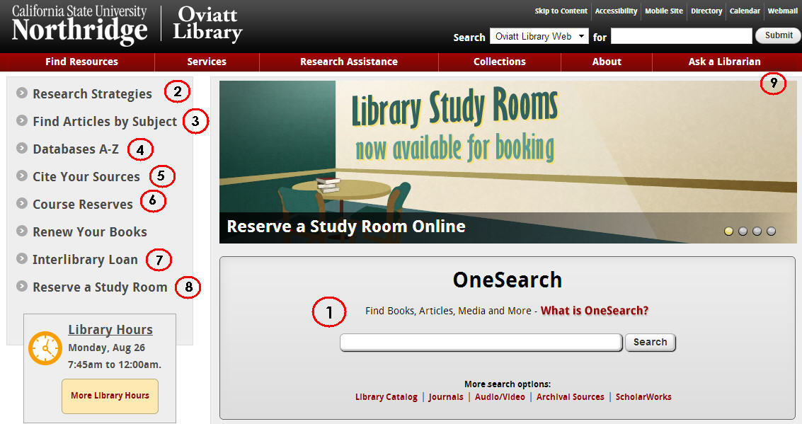
1.This central search box has several search options that will help you look for different things.

  - Use the “OneSearch” box to search the library’s databases and catalog for books, articles, dvds/videos, music and other things. To start, type your topic in the box and from the results choose either “Articles” tab for journal articles or “Books and Media” tab for catalog material.
  - “Library Catalog” option allows you to search for materials (like books, journals and dvds) in the library.
  - “Journals” tells you which magazines, newspapers and journals we have in the library or online. For a more detailed list of article databases by subject area, click the “Find Articles by Subject” link (#3).
  - “Audio/Video” explains how to search for sound recordings, videos and DVDs in the library catalog.
  - “Archival Sources” links to Special Collections & Archives Finding Aid Database.

  - “ScholarWorks” allows you to search for intellectual materials from CSUN faculty, staff and students.
- Research Strategies: Learn the basics of doing library research here.
- Databases by Subject: Browse our online databases to find individual articles by subject area. Most likely place to start is Databases by Subject: Physical Therapy
- Databases A-Z: If you know the article database you’re looking for, click here to get an A-Z list,
- Citing Your Sources: Note the link to EndNoteWeb and its tutorials. First time you create or register for your account sign up so your EndNote Basic account will have access to many style guides, such as style guide for the Physical Therapy journal. EndNote Basic (formerly known as EndNoteWeb also known as EndNote Online) is your FREE personal citation manager database IF you sign up, create your own free account. OneSearch, EbscoHost , Proquest, Web of Science databases have export functions- send bibliographic information into your personal EndNote Basic database. Once you created your own FREE EndNote Online (Basic) account (on campus) you can log in from anywhere using either http://my.endnote.com or http://myendnoteweb.com .Oviatt’s teaching computer labs have MicroSoftWord with the EndNote plugin. If you have Microsoft word on your own computer, you can download the free CiteWhileUWrite plugin on your personal computer. You can contact EndNote help desk, Monday-Friday 6 am (Pacific time) -4 pm call 800-336-4474 select Technical Support (press 4) then EndNote (press 1) or Email Physical Therapy librarian Marcia Henry at mhenry@csun.edu
- Course Reserves: Allows you to search for course reserves by Instructor or course number.
- Interlibrary Loan: If the library doesn’t own a book or article you need for your research, we can still try to get it for you from another library. Use 7. link to try this. Link to ILL login for items we do not own also available in databases on the menu.
- Reserve A Study Room: Use this link to reserve one of the library’s group or individual study rooms
- Ask a Librarian: Need research help? Physical Therapy Librarian is Marcia Henry Email: mhenry@csun.edu
Research Worksheet

Research Topic: _____________________________________________________________________________

___________________________________________________________________________________________

Key concepts or search terms:

____________________ ____________________ ____________________

____________________ ____________________ ____________________
Types of sources needed (check all that apply):
Boolean Searching Tip: AND vs OR (and truncation)
Useful in Ebscohost, Proquest, Gale, WOS databases)

Use AND between terms to narrow your search
e.g. (physical therap* OR physiotherap*) and child*

Use OR and/or truncate (*, ?) words to broaden your search
e.g. child* will retrieve child or children or childhood
(check online help for correct truncation symbol)

Books □
Scholarly Journal Articles □

OneSearch_-search150 databases, you can save to its electronic shelf (same login as your CSUN portal). Save records, view saved records, can export to EndNote Web (EndNOte Online or EmdNote Basic).

CINAHLPlus with Full Text (EbscoHost-- CINAHL subject headings, cited references, evidence based care sheets. Other EbscoHost databases Academic Search Elite, PsycInfo, ERIC & Education Fulltext, Wilson Omnifile, SportsDiscus. Records can Export to EndNote web

PubMed and MEDLINEPlus - indexes medical literature using the controlled vocabulary, MeSH headings, consumer health handouts in MEDLINEPlus (be sure to connect to Oviatt’s link to PubMed to for help from
to link into Oviatt’s subscriptions http://www.ncbi.nlm.nih.gov/pubmed?otool=cacsunlib

Library Catalog – catalog records for Oviatt’s books, journals, videos, sound record has link to WorldCat

Web of Science- a citation database indexing 14,000 journals from 1900- . Connects to EndNote Online . Same company (ISI) offers the MEDLINE(ISI) – (another version of PubMed)

PRIMAL Pictures Anatomy TV provides a dynamic interactive multimedia overview of human anatomy in the area of sports and therapy. Features three-dimensional animations that illustrate function and biomechanics. Videos and textual descriptions supplement the animations and models.

EndNoteWeb(also known as EndNote Online or EndNote Basic)_- sign up for a free account, helps you organize research, & citing for a variety of styles. Fpr example, APA 6th, JAMA, Physical Therapy

Need more research or citing help ? Email Marcia Henry mhenry@csun.edu

