Quick Guide to Oviatt Library’s Homepage: http://library.csun.edu

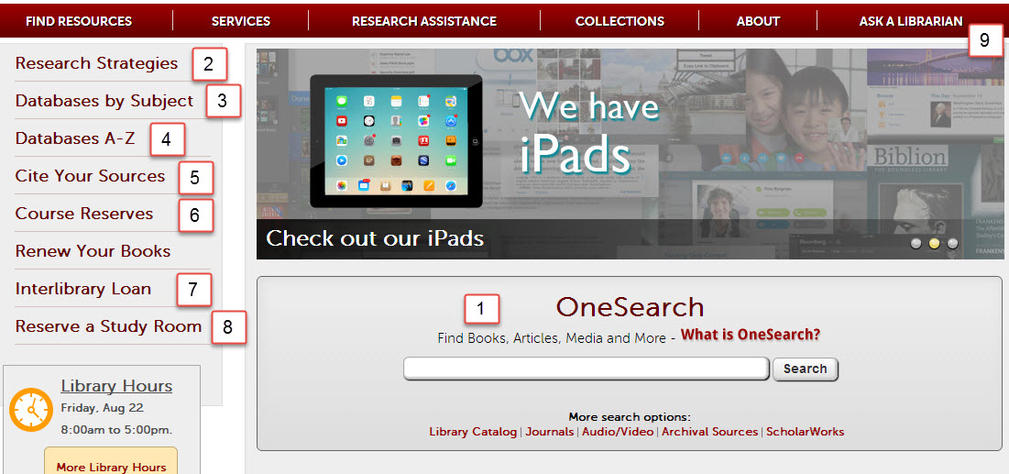

- This central search box has several search options that will help you look for different things.
  - Use the “OneSearch” box to search 150 databases and Oviatt catalog for books, articles, dvds/videos, music To start, type your topic in the box and from the results choose either “Articles” tab for journal articles or “Books and Media” tab for catalog material. Refine limits are on the left. Save record to export or email
  - “Library Catalog” option allows you to search for materials (like books, journals and dvds) in the library.
  - “Journals” advises which magazines, newspapers and journals we have in the library or online. For a more detailed list of article databases by subject area, click the “Find Articles by Subject” link (#3).
  - “Audio/Video” explains how to search for sound recordings, videos and DVDs in the library catalog.
  - “Archival Sources” links to Special Collections & Archives Finding Aid Database.

  - “ScholarWorks” allows you to search for intellectual materials from CSUN faculty, staff and students.
- Research Strategies: Learn the basics of doing library research here,
- Find Articles by Subject: Browse online databases to find individual articles by subject area. Subject: Kinesiology http://library.calstate.edu/northridge/databases/subject/kinesiology
- Databases A-Z: If you know the article database you’re looking for, click here to get an A-Z list,
- Citing Your Sources: See how to cite your research in APA other formats! Has links to EndNote and its tutorials. EndNote Basic (formerly known as EndNoteWeb also known as EndNote Online) is your free personal citation manager database IF you sign up on campus for a free account. OneSearch, EbscoHost , Proquest, Web of Science databases have export functions- send bibliographic information into your personal EndNote Basic (Online) database. Once registered connect from any computer anywhere http:/myendnoteweb.com
If you need help installing Cite While U Write plugin for Microsoft word call EndNote Technical Support at 800-336-4474 (listen for prompt then press 4 Technical Support, then press 1 for Endnote) Monday –Friday 6 am-5 pm Pacific Time
- Course Reserves: Allows you to search for course reserves by Instructor or course number.
- Interlibrary Loan: If the library doesn’t own a book or article you need for your research, we can still try to get it for you from another library. Use 7. link to try this. Link to ILL login for items we do not own also available in databases on the menu.
- Reserve A Study Room: Use this link to reserve one of the library’s group or individual study rooms.
- Ask a Librarian: Need research help from a librarian? You can come to the reference desk, call us, email us, text us or learn how to chat with a librarian online 24/7. Librarian speaking with you today is Marcia Henry email: mhenry@csun.edu .

Welcome Professor Javis’ KIN 445 class
Research Worksheet

Research Topic: study joint kinematics by comparing two different conditions for a movement (e.g. squat, jump, running)

Key concepts or search terms:

kinematics OR biomechanical

squat* OR jump* OR running
Boolean Searching Tip: AND vs OR (and truncation)
Useful in Ebscohost, Proquest, Gale, databases

Use AND between terms to narrow your search
Jump* AND (horizontal OR vertical) AND kinematic*

Use OR and/or truncate (*, ?) words to broaden your search
e.g. teen* will find teen, teens, teenager, teenagers
e.g. child* (will find child, children, childhood .)
(check online help for correct truncation symbol)
__________ OR _______________

Types of sources needed (check all that apply):

Scholarly Journal Articles □

Databases –select list of good resources

OneSearch_-searches over 150 databases, save records, view saved records, can export to EndNote Web.PubMed and MEDLINEPlus - indexes medical literature using the controlled vocabulary, MeSH headings, consumer health handouts in MEDLINEPlusCINAHLPlus with Full Text and several other Ebscohost databases (EbscoHost-- CINAHL subject headings, cited references,) Academic Search Elite, PsycInfo, ERIC (Education), SportsDiscus- all EbscoHost databases help with citing and export nicely to EndNoteWeb
Library Catalog – contains catalog record for all books, journals, videos, … Reserve items

Web of Science- a citation database indexing 14,000 journals from 1900- . Connects to EndNote Online

EndNote Online_(also called EndNote Web)- sign up for a free account, helps you organize research, cite APA Style example of journal articles with a DOI (digital object identifier)

Gheller, R. G., Dal Pupo, J., Ache-Dias, J., Detanico, D., Padulo, J., & dos Santos, S. G. (2015). Effect of different knee starting angles on intersegmental coordination and performance in vertical jumps. Human Movement Science, 42, 71-80. doi:10.1016/j.humov.2015.04.010
Sato, K., Fortenbaugh, D., Hydock, D. S., & Heise, G. D. (2013). Comparison of back squat kinematics between barefoot and shoe conditions. International Journal of Sports Science & Coaching, 8(3), 571-578. doi:10.1260/1747-9541.8.3.571
Name of Librarian:: Marcia Henry, Kinesiology Librarian, email: mhenry@csun.edu

