Quick Guide to Oviatt Library’s Homepage: http://library.csun.edu

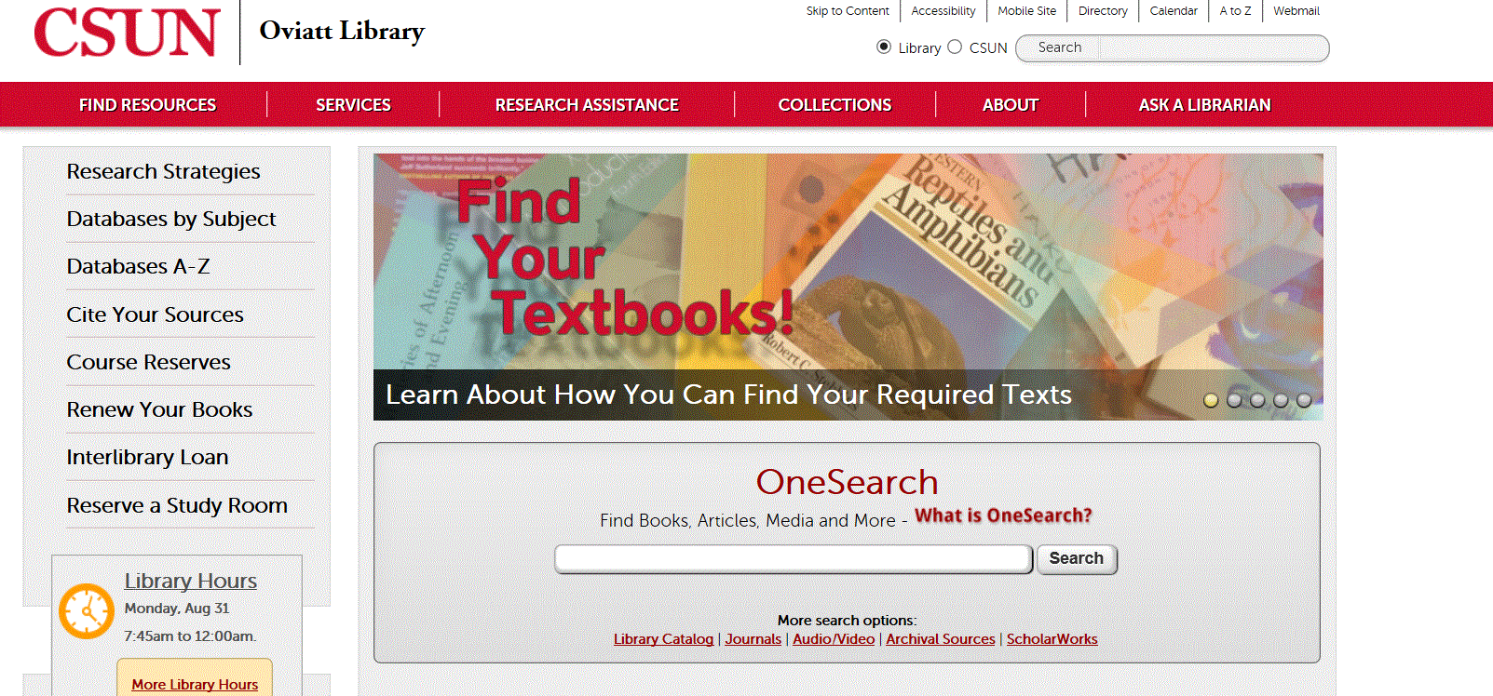

- This central search box has several search options that will help you look for different things.
  - Use the “OneSearch” box to search the library’s databases and catalog for books, articles, dvds/videos, music and other things. To start, type your topic in the box and from the results choose either “Articles” tab for journal articles or “Books and Media” tab for catalog material.
  - “Library Catalog” option allows you to search for materials (like books, journals and dvds) in the library.
  - “Journals” tells you which magazines, newspapers and journals we have in the library or online. For a more detailed list of article databases by subject area, click the “Find Articles by Subject” link (#3).
  - “Audio/Video” explains how to search for sound recordings, videos and DVDs in the library catalog.
  - “Archival Sources” links to Special Collections & Archives Finding Aid Database.

  - “ScholarWorks” allows you to search for intellectual materials from CSUN faculty, staff and students.
- Research Strategies: Learn the basics of doing library research here.
- Databases by Subject: Browse our online databases to find individual articles by subject area. Most likely place to start is Databases by Subject:Communication-Disorders + Sciences
- Databases A-Z: If you know the article database you’re looking for, click here to get an A-Z list,
- Citing Your Sources: See how to cite your research in APA format! Has links to EndNote and its tutorials. EndNote Basic (formerly known as EndNoteWeb also known as EndNote Online) is your free personal citation manager database. It is provided by the same company that offers us Web of Science. There is telephone support for CSUN students Monday-Friday,6 am-5 pm Pacific time. Endnote Web technical support's telephone number is 800-336-4474 (Press 4 Tech Support, wait for product EndNote, Press 1) Monday-Friday 6:00am-5:00 pm OneSearch, EbscoHost , Proquest, Web of Science databases have export functions- send bibliographic information into your personal EndNote Basic (also known as EndNote Online and EndNoteWeb)
- Course Reserves: Allows you to search for course reserves by Instructor or course number.
- Interlibrary Loan: If the library doesn’t own a book or article you need for your research, we can still try to get it for you from another library. Use 7. link to try this. Link to ILL login for items we do not own also available in databases on the menu.
- Reserve A Study Room: Use this link to reserve one of the library’s group or individual study rooms, up to 2 weeks in advance.
- Ask a Librarian: Need research help from a librarian? You can come to the reference desk, call us, email us, text us or learn how to chat with a librarian online 24/7.
The Librarian speaking to you today is Marcia Henry email: mhenry@csun.edu

The web page for Professor Sinclair’s is at http://library.csun.edu/Guides/CD502
Starting point to find databases can be either the class guide at http://library.csun.edu/guides/CD502 or
Databases by Subject: Communication Disorders+Sciences at http://library.calstate.edu/northridge/databases/subject/communication-disorders-sciences

Research Worksheet

Research Topic: _____________________________________________________________________________

___________________________________________________________________________________________

Key concepts or search terms:

____________________ ____________________ ____________________

____________________ ____________________ ____________________
Types of sources needed (check all that apply):
Boolean Searching Tip: AND vs OR (and truncation)
Useful in Ebscohost, Proquest, Gale, WOS databases)

Use AND between terms to narrow your search
Parkinson* AND (voice disorder* OR speech disorder*)
Use OR and/or truncate (*, ?) words to broaden your search
e.g. adoles* OR teen*
e.g. child* (will find child, children, childhood)
(check online help for correct truncation symbol)

Books □
Scholarly Journal Articles □

Databases demonstrated in sessions

CINAHLPlus with Full Text (EbscoHost-- CINAHL subject headings, cited references, evidence based care sheets
PubMed and MEDLINEPlus - indexes medical literature using the controlled vocabulary, MeSH headings, consumer health handouts in MEDLINEPlus
OneSearch_-searches over 150 databases, save records, view saved records, can export to EndNote Web.
Web of Science- a citation database indexing 14,000 journals from 1900- . Connects to EndNote Online, and also offers MEDLINE(ISI) database which offers most of the citations in PubMed with a different interface
EndNoteWeb_- sign up for a free account, helps you organize research, & citing APA Style
–example APA style below for a journal article with a DOI (digital object identifier) and a print book

Hanson, H. M. (1997). Glottal characteristics of female speakers: Acoustic correlates. Journal of the Acoustical Society of America, 101(1), 466-481. doi:10.1121/1.417991

Communication Disorders Librarian is Marcia Henry Best way to contact her is send email: mhenry@csun.edu

