Quick Guide to Oviatt Library’s Homepage: http://library.csun.edu

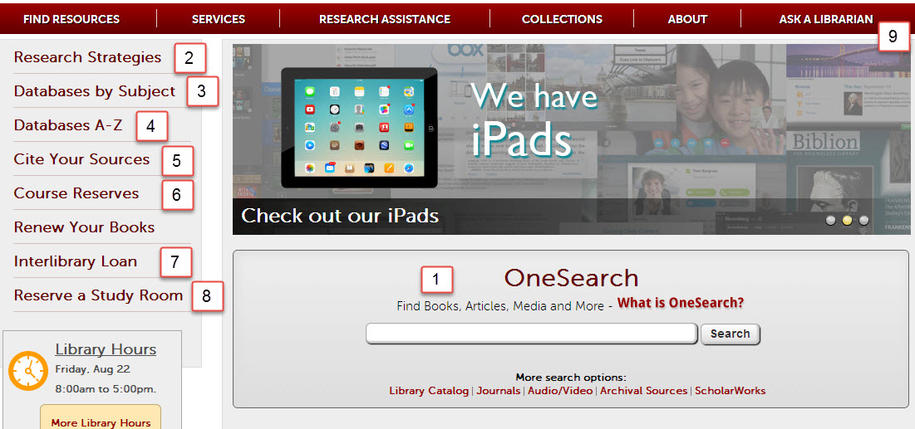

- This central search box has several search options that will help you look for different things.
  - Use the “OneSearch” box to search 150 databases and Oviatt catalog for books, articles, dvds/videos, music To start, type your topic in the box and from the results choose either “Articles” tab for journal articles or “Books and Media” tab for catalog material. Refine limits are on the left. Save record to export or email
  - “Library Catalog” option allows you to search for materials (like books, journals and dvds) in the library.
  - “Journals” advises which magazines, newspapers and journals we have in the library or online. For a more detailed list of article databases by subject area, click the “Find Articles by Subject” link (#3).
  - “Audio/Video” explains how to search for sound recordings, videos and DVDs in the library catalog.
  - “Archival Sources” links to Special Collections & Archives Finding Aid Database.

  - “ScholarWorks” allows you to search for intellectual materials from CSUN faculty, staff and students.
- Research Strategies: Learn the basics of doing library research here,
- Find Articles by Subject: Browse online databases to find individual articles by subject area. Subject: Health Sciences + Nursing at http://library.calstate.edu/northridge/databases/subject/health-sciences-nursing
- Databases A-Z: If you know the article database you’re looking for, click here to get an A-Z list,
- Citing Your Sources: See how to cite your research in APA and other formats! Full guide by Eric Garcia. Also has links to EndNote and its tutorials. EndNote Basic (formerly known as EndNoteWeb also known as EndNote Online) is your free personal citation manager database IF you sign up on campus for a free account. OneSearch, EbscoHost , Proquest, Web of Science databases have export functions- send bibliographic information into your personal EndNote Basic (Online) database. Once registered you can connect from any computer anywhere http:/myendnoteweb.com
- Course Reserves: Allows you to search for course reserves by Instructor or course number.
- Interlibrary Loan: If the library doesn’t own a book or article you need for your research, we can still try to get it for you from another library. Use 7. link to try this. Link to ILL login for items we do not own also available in databases on the menu.
- Reserve A Study Room: Use this link to reserve one of the library’s group or individual study rooms.
- Ask a Librarian: Need research help from a librarian? You can come to the reference desk, call us, email us, text us or learn how to chat with a librarian online 24/7.

The web page for Health Sciences 345 classes is at http://library.csun.edu/Guides/HSCI345

Librarian speaking to you today is Marcia Henry, Health Sciences Librarian Email: mhenry@csun.edu
The web page for Health Sciences 345 classes is at http://library.csun.edu/Guides/HSCI345
Research Worksheet
Research Topic: _____________________________________________________________________________

___________________________________________________________________________________________

Key concepts or search terms:

____________________ ____________________ ____________________
Boolean Searching Tip: AND vs OR (and truncation)
Useful in Ebscohost, Proquest, Gale, databases

Use AND between terms to narrow your search
legislat* AND California AND (Marijuana or Cannabis)

Use OR and/or truncate (*, ?) words to broaden your search
e.g. teen* will find teen, teens, teenager, teenagers
e.g. child* (will find child, children, childhood .)
(check online help for correct truncation symbol)

Types of sources needed

Scholarly Journal Articles
Trade journals
Newspapers

Websites demonstrated
MedlinePlus at http://medlineplus.gov
Also offers health news at
http://www.nlm.nih.gov/medlineplus/healthnews.html

Offical California Legislative Information gives status and history of bills at http://leginfo.legislature.ca.gov/faces/billSearchClient.xhtml
California State assembly at http://assembly.ca.gov/assemblymembers
California Senate at http://senate.ca.gov/
Databases demonstrated in sessions
OneSearch_- 150 databases, 2 tabs, electronic shelf, save records, view saved records, can export to EndNote
CINAHLPlus with Full Text (EbscoHost-- CINAHL subject headings, cited references, evidence based care sheets (Cumulative Index to Nursing and Allied Health Literature=CINAHL) + 24 databases
PubMed and MEDLINEPlus - indexes medical literature using the controlled vocabulary, MeSH headings, consumer health handouts in MEDLINEPlus
Proquest databases –has 19 databases Newspapers (Los Angeles Times, Los Angeles Daily News)
LEXIS/Nexis Academic - legislation, newspaper articles, and more-
Library Catalog – contains catalog record for all books, journals, videos, sound records Library has
EndnoteWeb_- sign up (http://library.csun.edu/restricted/endnote.scr) for a free account, organize research, cite APA Style. Examples below of APA style for an online journal article without a DOI(digital object identifier) and an example of how to cite a California Bill. APA style adopts the Blue Book style for legal citations,

Assem. Bill 445, 2013-2014 Reg. Sess. (Cal. 2014).

http://www.leginfo.ca.gov/pub/13-14/bill/asm/ab_1201-1250/ab_1249_bill_20140106_amended_asm_v98.pdf

Baker, A. (2010). California passes water management legislation for the future. Journal of the American Water Works Association, 102(1), 16-18. Retrieved from http://www.jstor.org/stable/41313793.
Need research help? Contact Marcia Henry, Health Sciences Librarian at mhenry@csun.edu

