Quick Guide to Oviatt Library’s Homepage: http://library.csun.edu

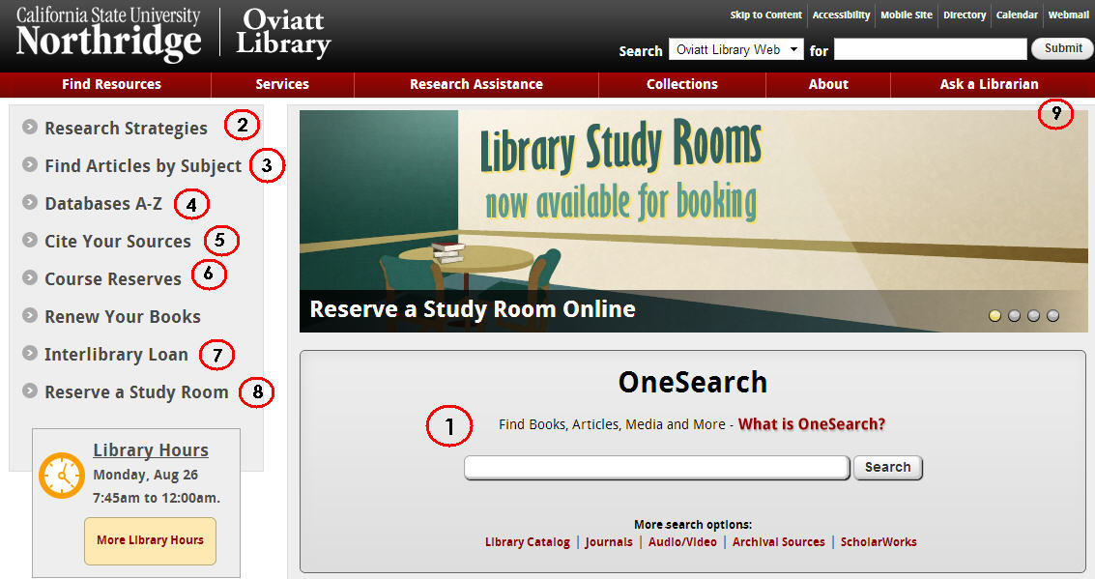

- This central search box has several search options that will help you look for different things.
  - Use the “OneSearch” box to search the library’s databases and catalog for books, articles, dvds/videos, music and other things. To start, type your topic in the box and from the results choose either “Articles” tab for journal articles or “Books and Media” tab for catalog records for books, journals, videos, and more
  - “Library Catalog” option allows you to search for materials (like books, journals and dvds) in the library.
  - “Journals” tells you which magazines, newspapers and journals we have in the library or online. For a more detailed list of article databases by subject area, click the “Find Articles by Subject” link (#3).
  - “Audio/Video” explains how to search for sound recordings, videos and DVDs in the library catalog.
  - “Archival Sources” links to Special Collections & Archives Finding Aid Database.

  - “ScholarWorks” allows you to search for intellectual materials from CSUN faculty, staff and students.
- Research Strategies: Learn the basics of doing library research here.
- Find Articles by Subject: Browse our online databases to find individual articles by subject area.
- Databases A-Z: If you already know the article database you’re looking for, click here to get an A-Z list of all our databases.
- Citing Your Sources: See how to cite your research in APA format! Notice EndNote and its tutorials. EndNote Basic (formerly known as EndNoteWeb) is your free personal citation manager database IF you sign up for a free account. OneSearch, EbscoHost and Proquest databases have export functions- send bibliographic information into your personal EndNote Basic database. You can edit and add research notes to improve, format to cite APA 6th
- Course Reserves: Allows you to search for course reserves by Instructor or course number.
- Interlibrary Loan: If the library doesn’t own a book or article you need for your research, we can still try to get it for you from another library. Use 7. link to try this. Link to ILL login for items we do not own also available in databases on the menu.

- Reserve A Study Room: Use this link to reserve one of the library’s group or individual study rooms, up to 2 weeks in advance

- Ask a Librarian: Need research help from a librarian? You can come to the reference desk, call us, email us, text us or learn how to chat with a librarian online 24/7. Librarian speaking to you today is Marcia Henry email: mhenry@csun.edu The web page for Professor Ward’s class is at http://library.csun.edu/Guides/RTM300
The web page for Professor Ward’s class is at http://library.csun.edu/Guides/RTM300
Research Worksheet
Research Topic: _____________________________________________________________________________

Key concepts or search terms:

____________________ ____________________ ____________________

Boolean Searching Tip: AND vs OR (and truncation)
(Useful in Ebscohost, Proquest, Gale, library catalog)

Use AND between terms to narrow your search -e.g. (leisure OR recreation* ) AND national parks
Use OR and/or truncate (*, ?) words to broaden your search
e.g. recreation* OR sports OR games
e.g. child* (will find child, children, childhood .)
(check online help for correct truncation symbol)
Types of sources needed (check all that apply):

Books □
Scholarly Journal Articles □
Websites
Information about community
Healthy City at http://www.healthycity.org/
San Fernando Valley Statistics and Facts at
http://library.csun.edu/Guides/SFValley

Databases demonstrated

- OneSearch -150 databases
- EbscoHost databases –Academic Search Premier, CINAHLPlus (Nursing & Allied Health) , PsycInfo, ERIC, Business
- Proquest –ABI/Inform, GenderWatch
Library Catalog - Do we own these titles?: Journal of Leisure Research? Los Angeles Times?
APA Style –examples below—journal library owns in print, free online article, article with doi Idigital object identifier)
Anderson, D. M., & Shinew, K. J. (2001). A national examination of gender equity in public parks and recreation. Journal of Leisure Research, 33(4), 470-491.

Carlson, S. A., Brooks, J. D., Brown, D. R., & Buchner, D. M. (2010). Racial/ethnic differences in perceived access, environmental barriers to use, and use of community parks. Preventing Chronic Disease, 7(3), 1-10. Retrieved September 22, 2013, from http://www.ncbi.nlm.nih.gov/pmc/articles/PMC2879981/pdf/PCD2879973A2879949.pdf.
Shinew, K. J., Floyd, M. F., & Parry, D. (2004). Understanding the relationship between race and leisure activities and constraints: Exploring an alternative framework. Leisure Sciences, 26(2), 181-199. doi: 10.1080/01490400490432109
Need research help? Email Marcia Henry, RTM Librarian- mhenry@csun.edu

