Quick Guide to Oviatt Library’s Homepage: http://library.csun.edu

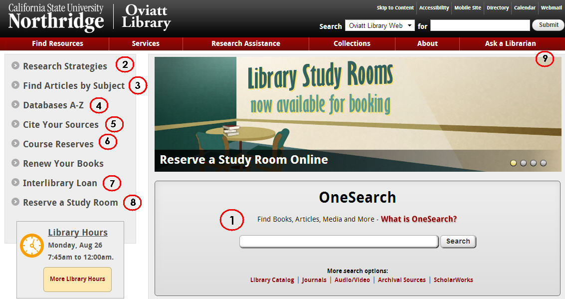

- This central search box has several search options that will help you look for different things.
  - Use the “OneSearch” box to search the library’s databases and catalog for books, articles, dvds/videos, music and other things. To start, type your topic in the box and from the results choose either “Articles” tab for journal articles or “Books and Media” tab for catalog material.
  - “Library Catalog” option allows you to search for materials (like books, journals and dvds) in the library.
  - “Journals” tells you which magazines, newspapers and journals we have in the library or online. For a more detailed list of article databases by subject area, click the “Find Articles by Subject” link (#3).
  - “Audio/Video” explains how to search for sound recordings, videos and DVDs in the library catalog.
  - “Archival Sources” links to Special Collections & Archives Finding Aid Database.

  - “ScholarWorks” allows you to search for intellectual materials from CSUN faculty, staff and students.
- Research Strategies: Learn the basics of doing library research here.
- Find Articles by Subject: Browse our online databases to find individual articles by subject area. Most likely place to start is Find Articles by Subject: Communication Disorders & Sciences
- Databases A-Z: If you know the article database you’re looking for, click here to get an A-Z list,
- Citing Your Sources: See how to cite your research in APA format! Note the link to EndNoteWeb and its tutorials. EndNote Basic (formerly known as EndNoteWeb also known as EndNote Online) is your FREE personal citation manager database IF you sign up, create your own free account. OneSearch, EbscoHost , Proquest, Web of Science databases have export functions- send bibliographic information into your personal EndNote Basic database. Once you create your own FREE EndNote Online (Basic) account you can log in using either http://my.endnote.com or http://myendnoteweb.com . You can contact EndNote help desk, Monday-Friday 6 am (Pacific time) -4 pm call 800-336-4474 select Technical Support (press 4) then EndNote (press 1)
- Course Reserves: Allows you to search for course reserves by Instructor or course number.
- Interlibrary Loan: If the library doesn’t own a book or article you need for your research, we can still try to get it for you from another library. Use 7. link to try this. Link to ILL login for items we do not own also available in databases on the menu.
- Reserve A Study Room: Use this link to reserve one of the library’s group or individual study rooms
- Ask a Librarian: Need research help from a librarian? You can come to the reference desk, call us, email us, text us or chat with a librarian online 24/7. Librarian speaking to you is Marcia Henry email:mhenry@csun.edu

Find databases by Subject: Communication Disorders at http://library.calstate.edu/northridge/databases/subject/communication-disorders-sciences

Research Worksheet

Research Topic: _____________________________________________________________________________

Key concepts or search terms:

____________________ ____________________ ____________________

____________________ ____________________ ____________________
Types of sources needed (check all that apply):
Boolean Searching Tip: AND vs OR (and truncation)
Useful in Ebscohost, Proquest, Gale, WOS, OneSearch

Use AND between terms to narrow your search
stutter* AND (therapy OR assess*)

Use OR and/or truncate (*, ?) words to broaden your search
e.g. adoles* OR teen*
e.g. child* (will find child, children, childhood .)
(check online help for correct truncation symbol)

Books □
Scholarly Journal Articles □

Databases demonstrated in sessions

OneSearch_-searches over 150 databases, save records, view saved records, can export to EndNote Web.
MEDLINE (ISI) – Web of Science interface gives different view of PubMed records-easy save to EndNote Online view videos on YouTube e,g http://tinyurl.com/z8x2ba4
CINAHLPlus with Full Text (EbscoHost-- CINAHL subject headings, cited references, evidence based care sheets. Other EbscoHost databases Academic Search Elite, PsycInfo, ERIC & Education Fulltext, Wilson Omnifile. Records can be Export to EndNote web
PubMed and MEDLINEPlus - indexes medical literature using the controlled vocabulary, MeSH headings, consumer health handouts in MEDLINEPlus
Library Catalog – catalog records for Oviatt’s books, journals, videos, sound record has link to WorldCat
Web of Science- a citation database indexing 14,000 journals from 1900- . Connects to EndNote Online
EndNoteWeb_(also called EndNote Basic, EndNote Online)- sign up for a free account, helps you organize research, & citing–examples APA style for a journal article with a DOI (digital object identifier) and a book

Gallop, R. F., & Runyan, C. M. (2012). Long-term effectiveness of the SpeechEasy fluency-enhancement device. Journal of Fluency Disorders, 37(4), 334-343. doi:10.1016/j.jfludis.2012.07.001
Yairi, E., & Seery, C. H. (2015). Stuttering : Foundations and clinical applications. Boston: Pearson Allyn & Bacon.

Need help? contact Marcia Henry, Communication Disorders Librarian Email: mhenry@csun.edu

