Windows Reset Guide
NOTE This process can take an hour or more to complete please make sure the device remains connected to power and internet for the duration of the process

Step 1: Power on the PC and sign in with your CSUN email address and password
Step 2: Open the search bar.
Click the search bar at the bottom of the screen.
Type "Reset this PC" and select the option shown.
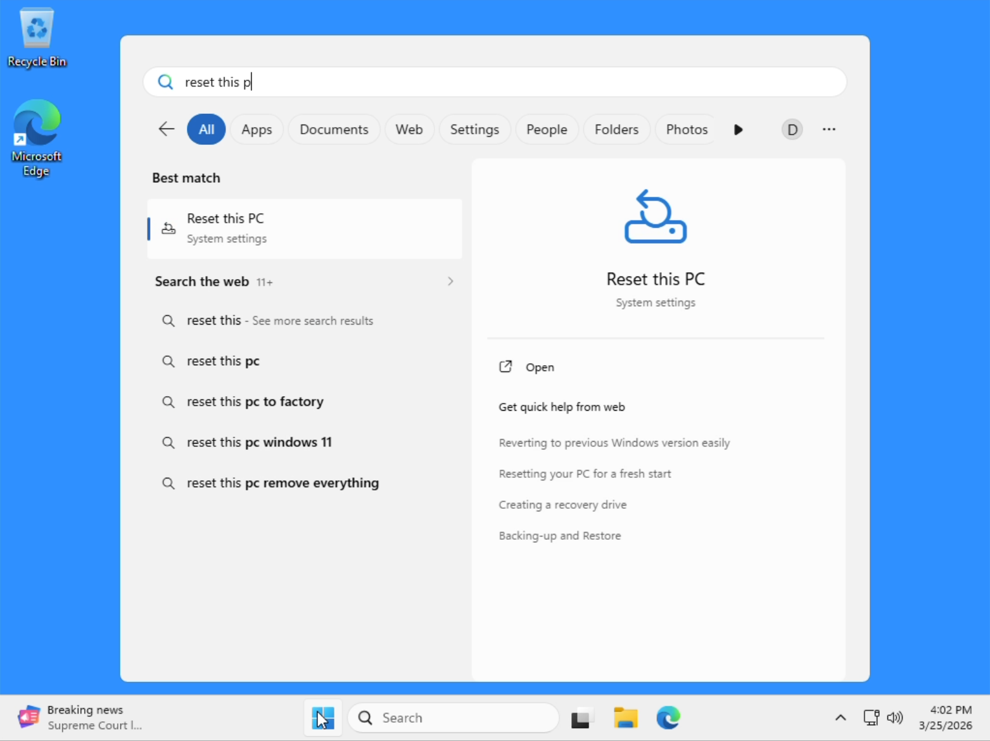

Step 3: Start reset.
Click Reset PC.
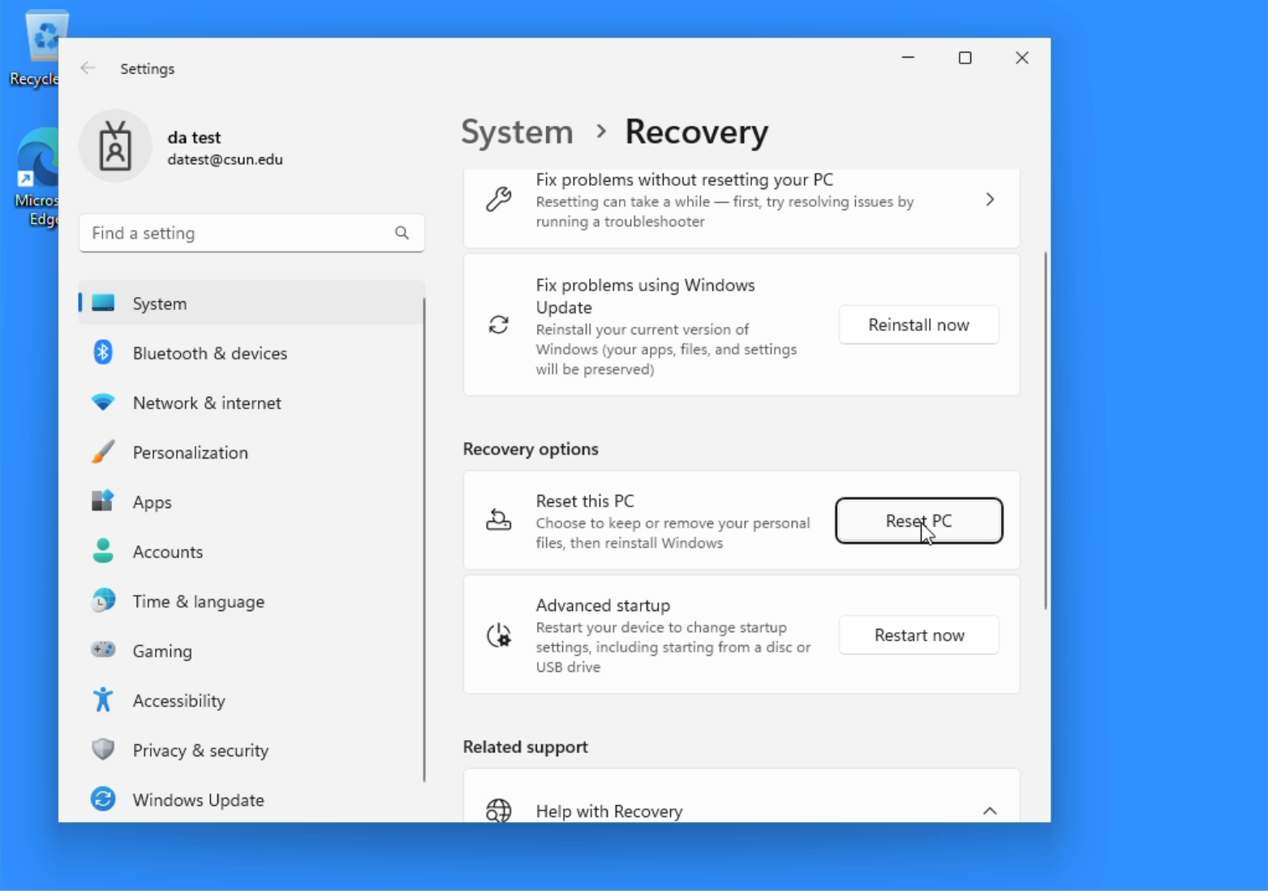

Step 4: Choose reset type.
Select Remove everything.
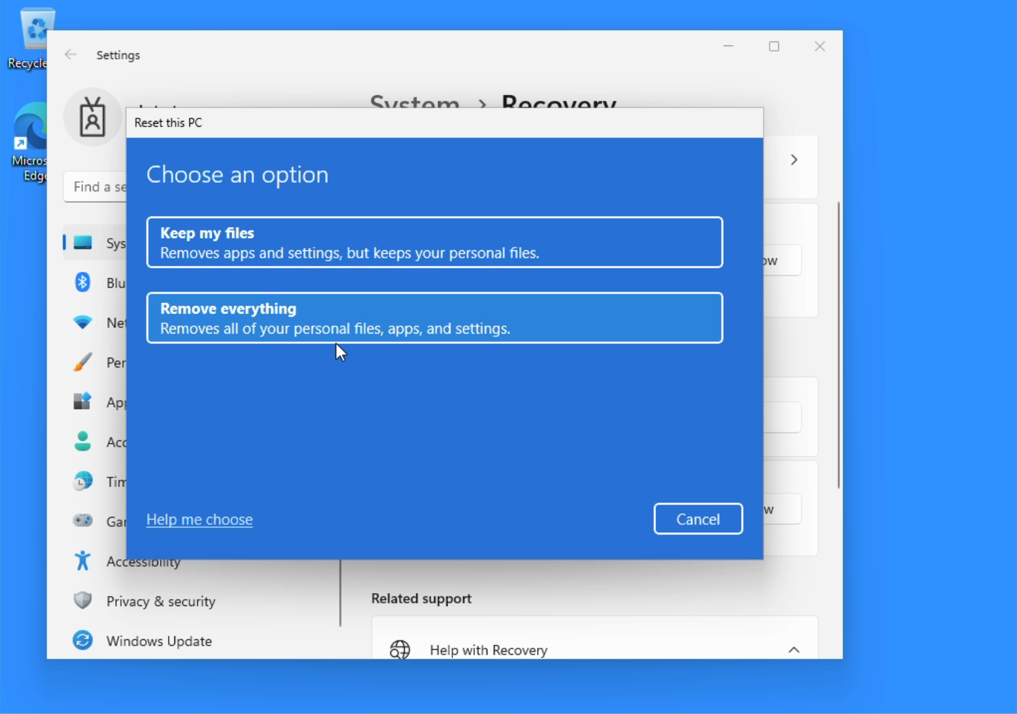

Step 5: Select reinstall method.
Choose “Local reinstall”
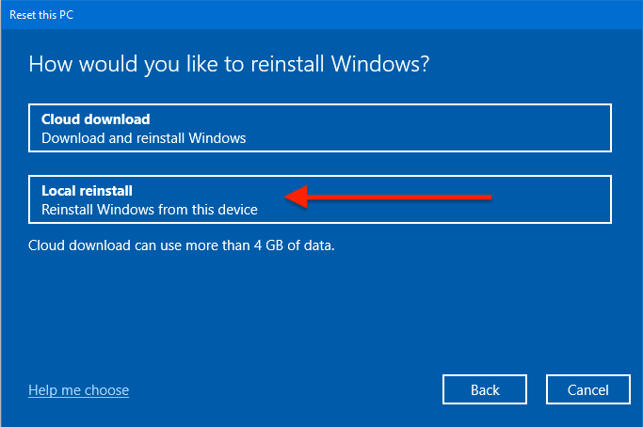

Step 6: Confirm reset.
Click Next until you see “Ready to reset this PC”, then click Reset to begin.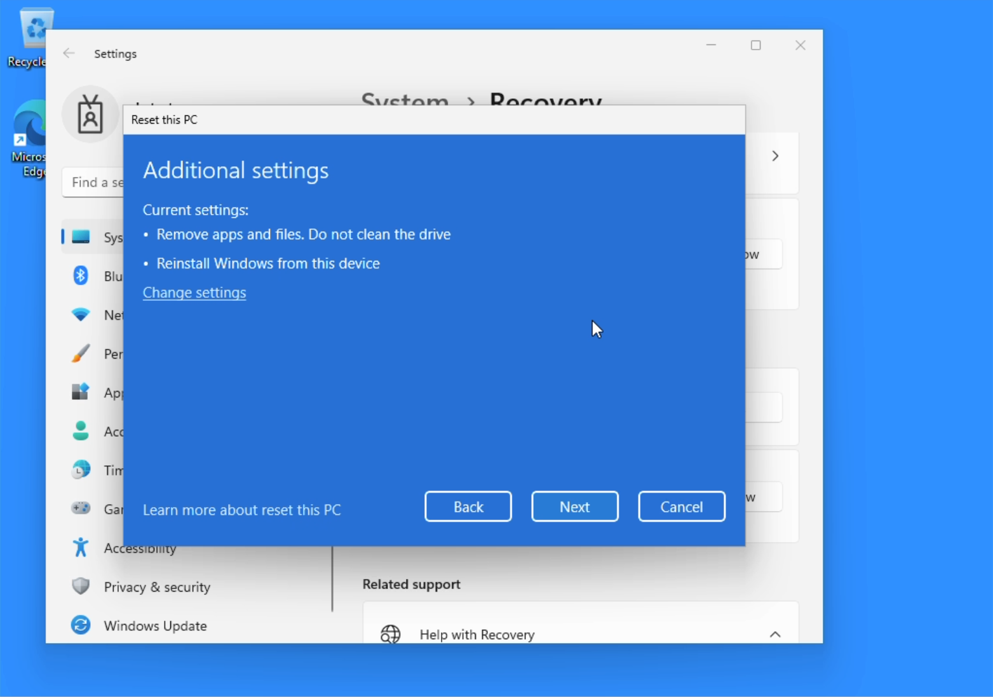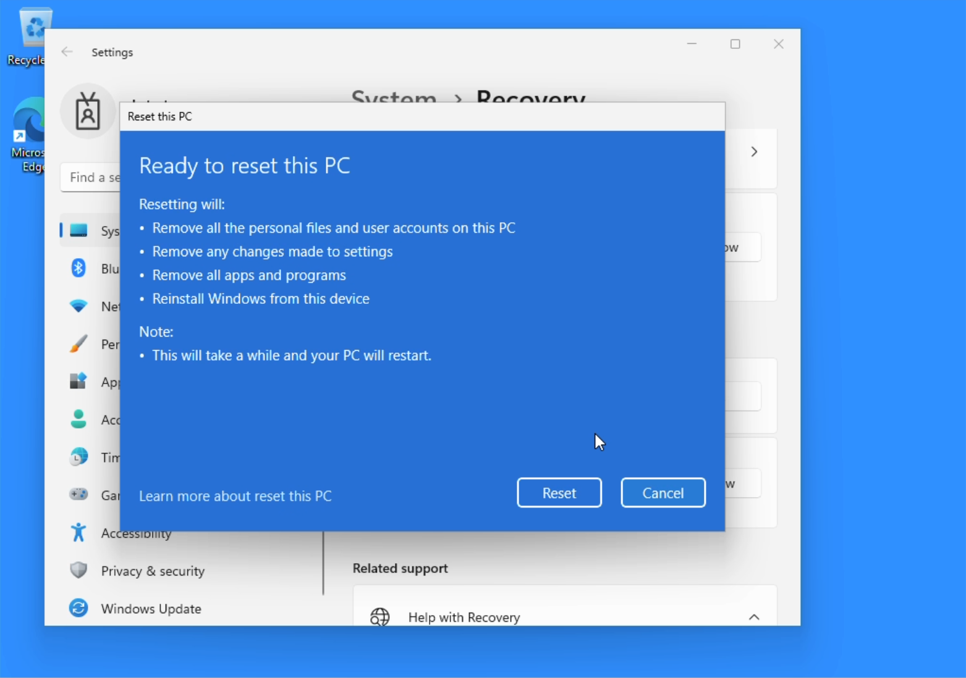

Step 7: Wait for reset to complete.
The reset process can take up to an hour or more, make sure you have ample time to leave the device plugged into power and connected to the network.
You will see multiple screens during this process.
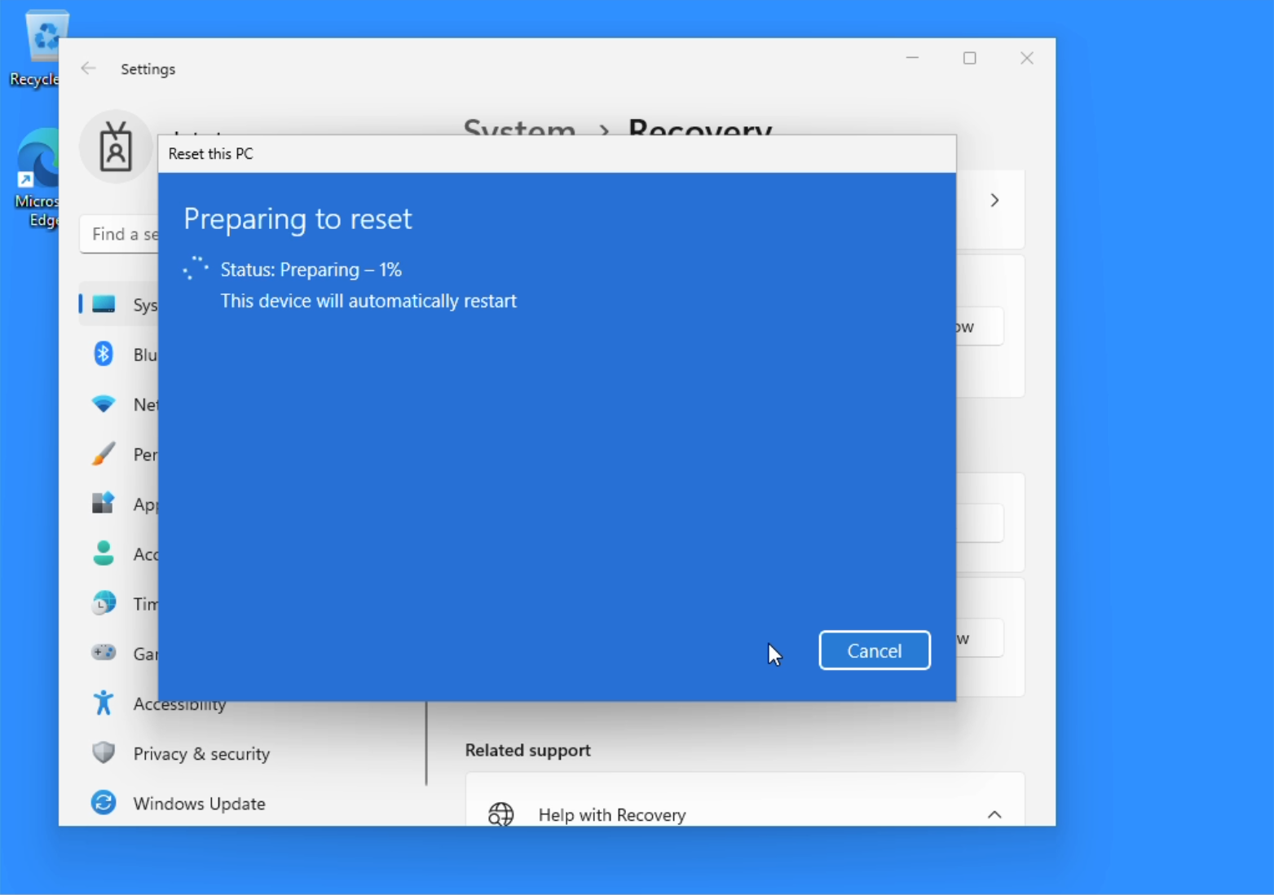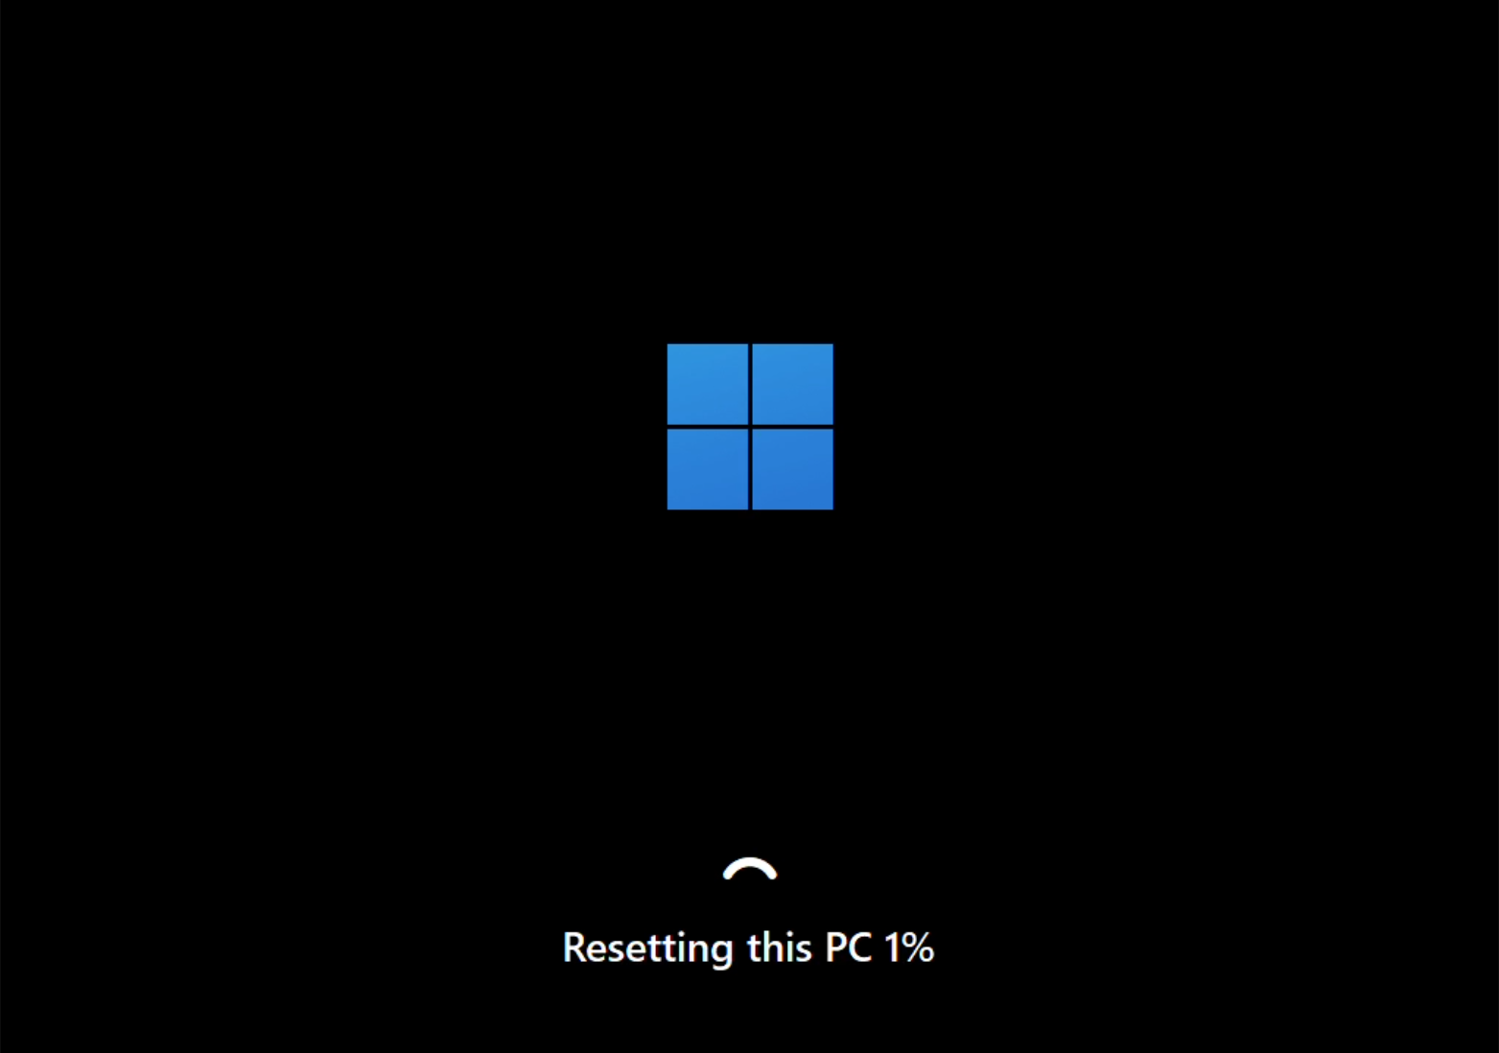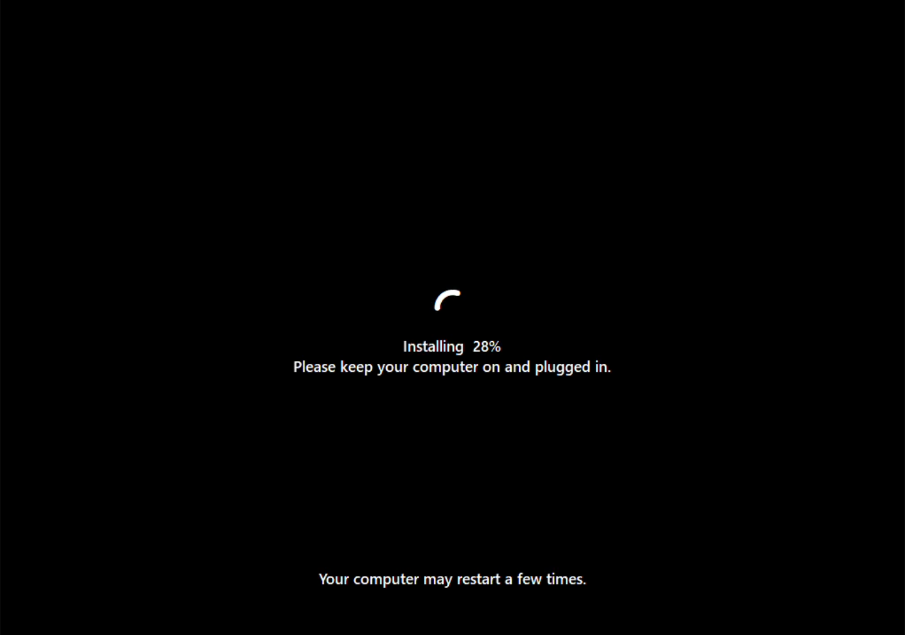

Step 8: Finish.
When you see the Select region screen, the reset is complete.
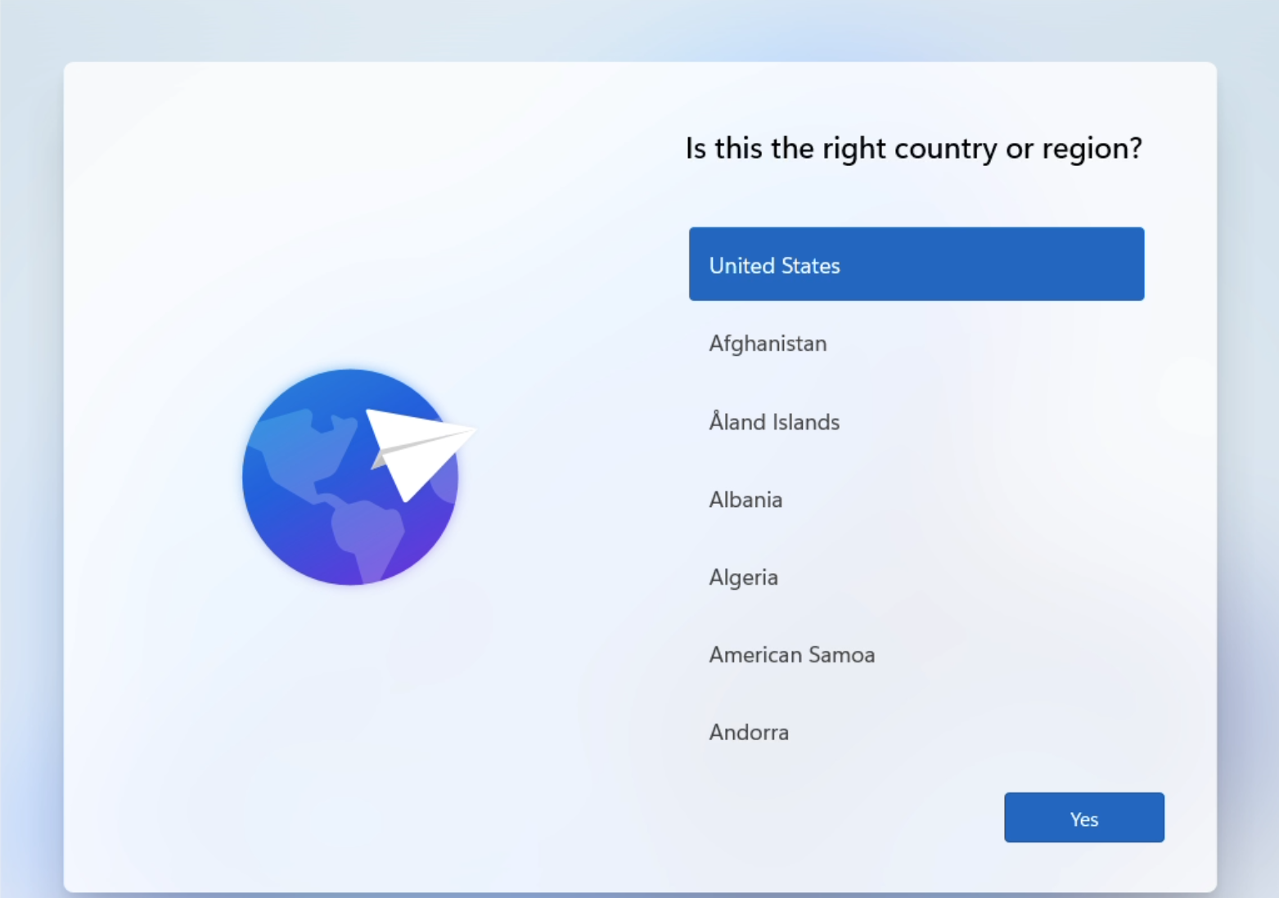

NOTE: If you are returning the device, stop here.
If you are keeping the device, continue with setup.

Troubleshooting Common Issues
- The computer failed to reset, displayed an error during the process, or appears stuck resetting.
a. Return the device to the library and inform staff that the reset process failed.
- I received a message stating administrator access is required to reset the computer.
a. Return the device to the library and inform staff that the reset process failed.

Please contact the IT Help Center if you run into any issues resetting your device.
818-677-1400

