Windows Loaner Setup Guide

PLEASE ALLOW UP TO 1 HOUR FOR THE SETUP TO COMPLETE

Step 1: Power on the laptop.
Press the power button to turn on the device.

Step 2: Select region and keyboard.
Select United States for your region, and US for your keyboard.
Click Skip when prompted to a second keyboard

Step 3: Connect to Wi-Fi.
Select a wireless network.
If on campus, select Eduroam and sign in using your CSUN email address and password.

Step 4: Sign in with your CSUN account.
You will have to sign in multiple times during this process
Confirm that you see the CSUN logo and enter your CSUN email address. See image below.
NOTE: If CSUN logo is not displayed.
Hold the power button to shut down the laptop.
Turn it back on and try again.

If you see the message “There was an issue looking up your account. Tap Next to try again.” Keep pressing next until you are forwarded to the CSUN SSO login page

Click Next to be redirected to the standard CSUN login page.
Sign in with your CSUN credentials and complete Duo authentication. Select “Yes, this is my device.”
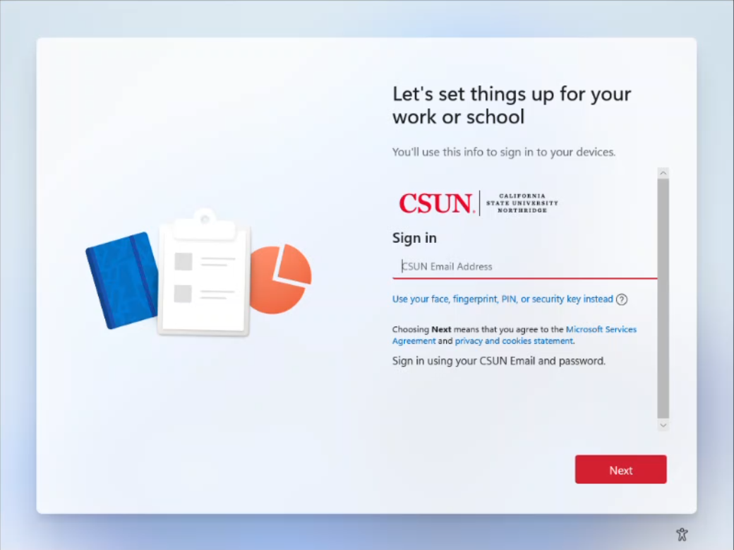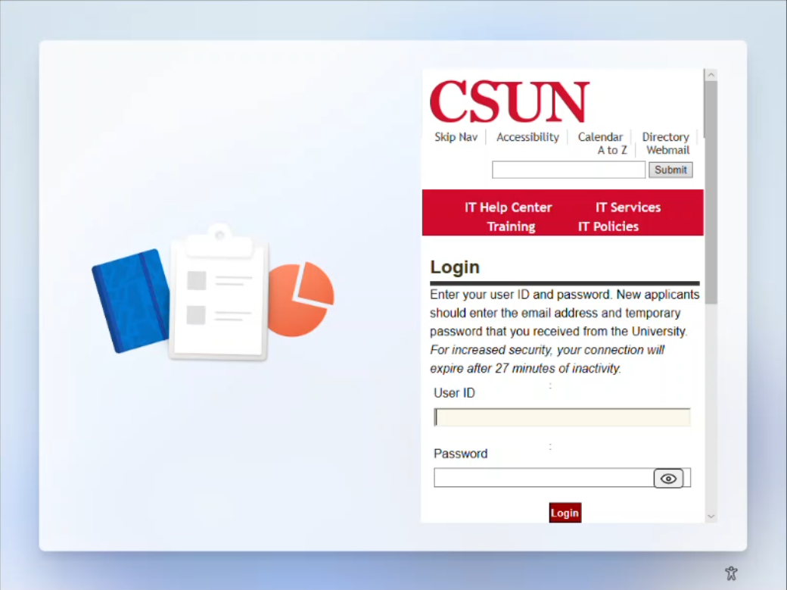

NOTE: If account lookup fails.
Verify your email address is correct.

Step 5: Sign in again.
You will be redirected back to the login page. This is expected.
Sign in again using your CSUN credentials.
Step 6: Microsoft Account MFA
NOTE If DUO MFA does not appear or you are asked for Microsoft Authenticator look for the “Sign in another way” blue link then select “Approve with DUO MFA”. If this link is not available please call the help center at 818-677-1400

DUO MFA
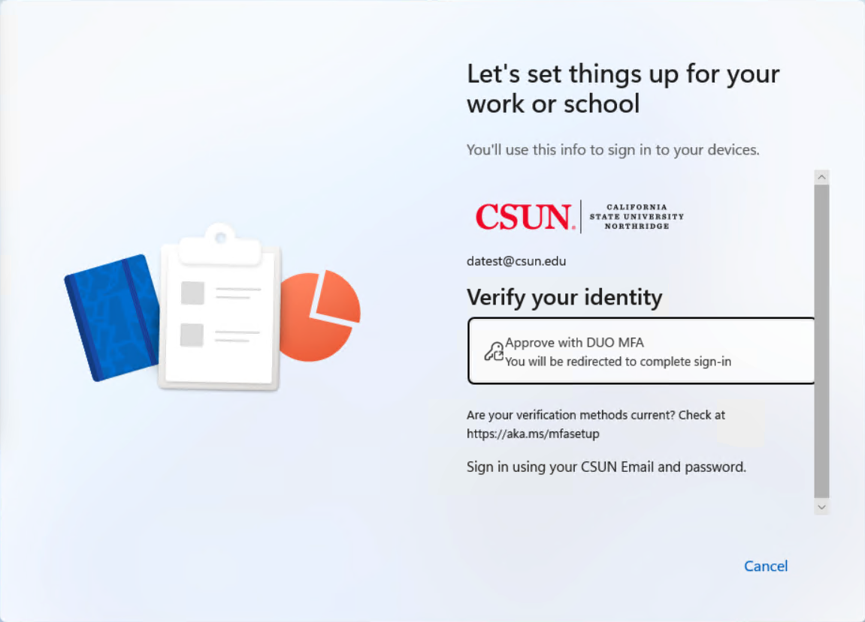

Sign in another way.
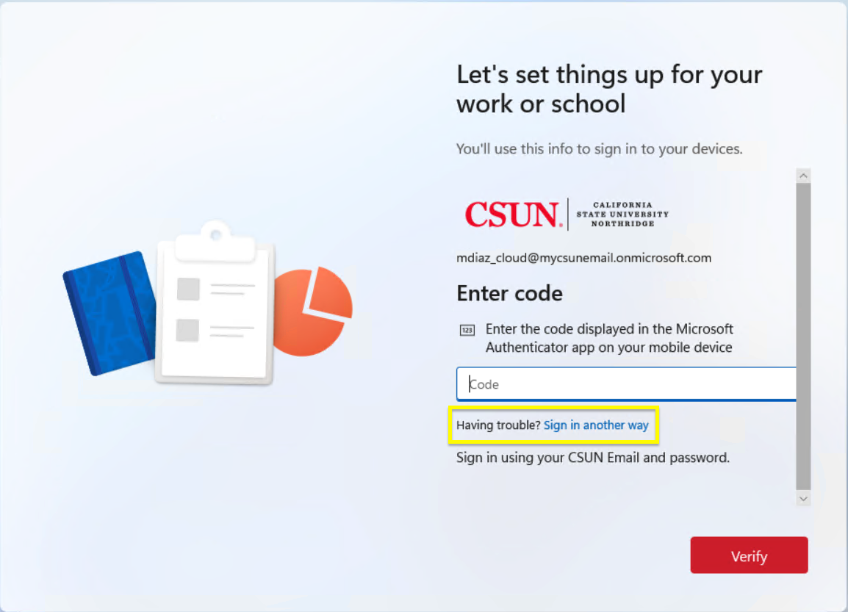

Step 7: Complete authentication.
Sign in if asked and accept any DUO prompts.

Step 8: Allow device setup to complete.
You will see “Setting up for work or school.”
Do not turn off the device or close the lid during this process.
WARNING: Interrupting setup may result in an incomplete configuration.
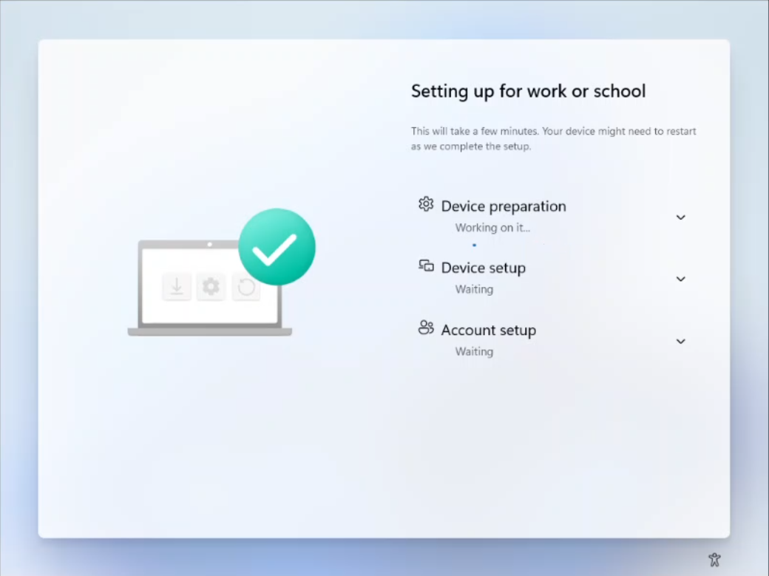
Step 9: Finish.
When you reach the sign-in screen or Windows desktop, setup is complete.
You may now use your loaner laptop.

Company Portal

To install additional software please use the Company Portal application which is already installed on your device.
To find company portal click the Start Menu in the center of the toolbar and type “Company Portal”

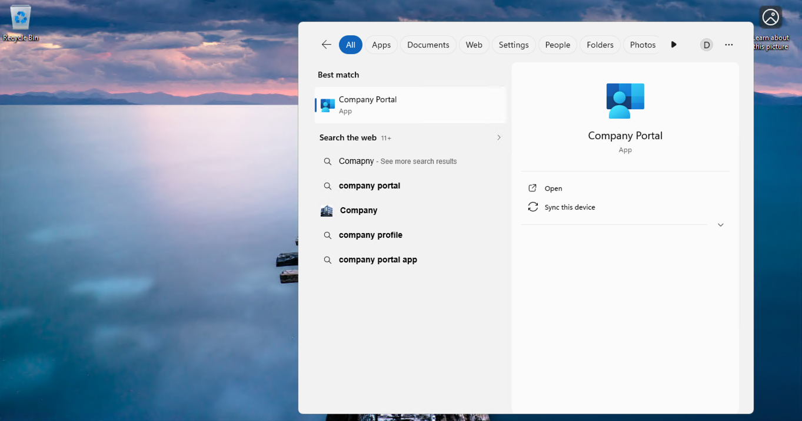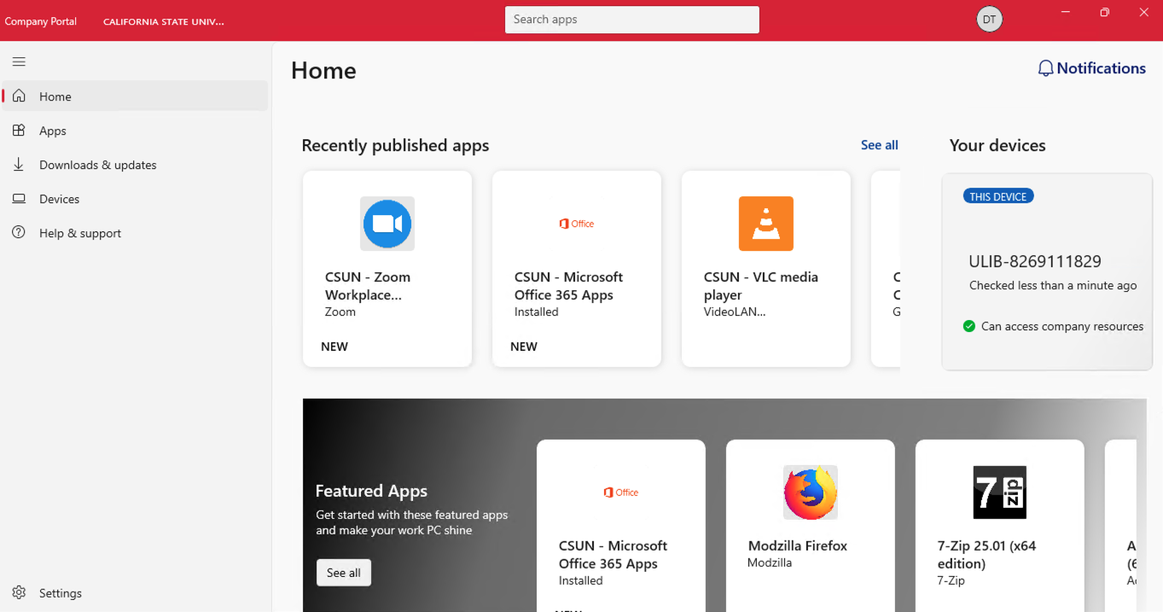

Troubleshooting Common Issues
- During Step 4, I receive the message “There was an issue looking up your account. Tap Next to try again.”
a. Verify your email address and continue selecting Next until you reach the CSUN SSO sign-in page. If the message continues indefinitely, contact the Help Center at 818-677-1400.
- I keep getting asked to sign in.
a. Verify there are no messages indicating your email or password is incorrect. Multiple sign-ins are expected during setup. If the device never progresses past the sign-in screen, exchange it at the Library Guest Services desk.
- I see the message “Oops, you’ve lost internet connection.”
a. Hold the power button for 30 seconds to shut down the laptop, then try setup again. If the issue continues, contact the Help Center or exchange the device.
- I don’t see Company Portal.
a. Wait up to 10 minutes for Company Portal to install. If it still does not appear, contact the Help Center at 818-677-1400.
- I am asked whether I want to set up the device for Personal Use or Work or School.
a. Restart the computer and verify the CSUN logo appears during Step 4. If it does not, exchange the device at the Library Guest Services desk.
- I am asked to enter a computer name or my own name.
a. The device was not configured correctly. Complete setup, then follow the reset guide to reset the device again, or exchange it at the library.
- I see setup screens not covered in this guide.
a. If you saw the CSUN logo during Step 4, Microsoft has added new setup screens. Make the appropriate selections and continue.
b. If you did not see the CSUN logo during Step 4, complete setup, then reset or exchange the device.
- I don’t receive a Duo prompt, I see “Authentication methods are available,” or have other Duo issues.
a. Contact the Help Center at 818-677-1400.
- I don’t have access to Microsoft Authenticator or the phone number shown during Step 8.
a. Select Sign in another way and choose Duo MFA. If that option is unavailable, contact the Help Center to reset your Microsoft MFA methods.
- I see errors after Step 8.
a. Select Continue Anyway. Failed processes will automatically retry.
OR
b. Select Reset Device and start over. If the issue persists, continue using the device if possible or exchange it at the Library Guest Services desk.
- My computer is missing software.
a. Software installation may take up to an hour. If it is still missing, check Company Portal and install it manually. If it is not available there, install it from the developer’s website.
- After setup, I receive the message “We are unable to connect right now. Please check your network and try again later.”
a. Connect to the internet and sign in again. This only needs to be done once. Offline sign-in will work afterward.

For any issues not covered here, please contact the IT Help Center at 818-677-1400 or visit the Ask-a-Tech help desk located on the first floor of the library towards the back wall.

