iPad Reset Guide

The reset and setup process can take up to 30 minutes or more please make sure you have time to complete it in one sitting.

NOTE PRIOR TO RESETTING

YOU MUST UPDATE iOS if not on at least iOS 16
How to check: Settings>General>About>iOS Version
How to update: Settings>General>Software Update> Download and Install
Please make sure to back up your data before resetting your device.

You have a few options:

Recommended option:
- Use your Apple ID to create an iCloud backup.
- This is the easiest and most complete method, but it may require a paid iCloud subscription if you have more than 5gb of data you need to backup.
- If you don’t have one and would like to set it up, instructions are available at the link below under “New AppleID”
Other options:
- You can manually back up your files using Google Drive or myCSUNBox.
- Please note that this is a manual process, so be sure to confirm all important files are uploaded before resetting.
Important:
- App data is not included when using Google Drive, Box, or other cloud storage.
- Only iCloud Backup includes app data.
- Some apps may have their own backup or sync options, so check within the app if needed.

New AppleID
https://support.apple.com/en-us/108647?device-type=mac

iCloud Backup
https://support.apple.com/en-us/108366

Upload Files to Google Drive
https://support.google.com/drive/answer/2424368?hl=en&co=GENIE.Platform%3DiOS

Upload Files to myCSUNBox
https://support.box.com/hc/en-us/articles/360044195633-Manage-Your-Content-with-Box-for-iOS

If you need assistance with any of the steps mentioned in this guide please contact our Help Center at 818-677-1400 or visit the Ask-A-Tech help desk located in the first floor of the library towards the back wall.

Step 1: Open Settings.
Tap Settings on your iPad home screen.
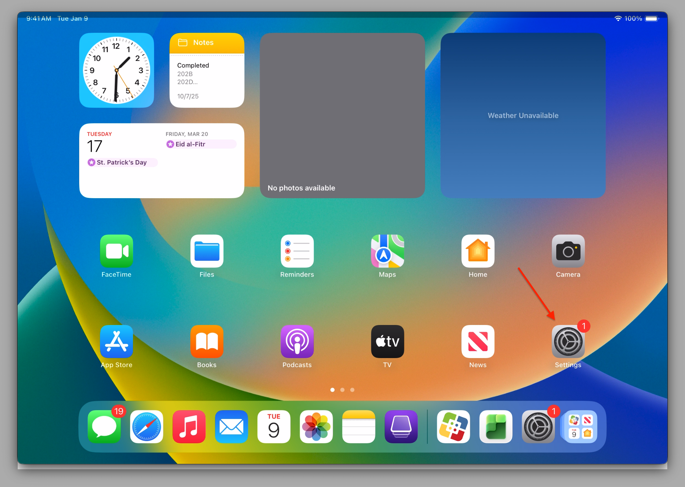

Step 2: Go to General.
Tap General.
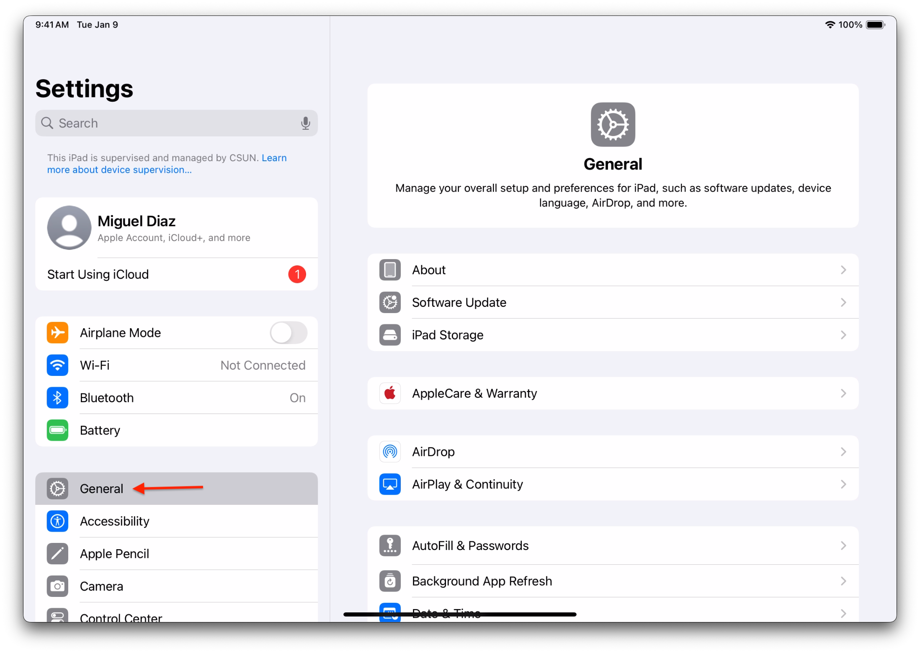

Step 3: Open reset options.
Scroll down and tap Transfer or Reset iPad.
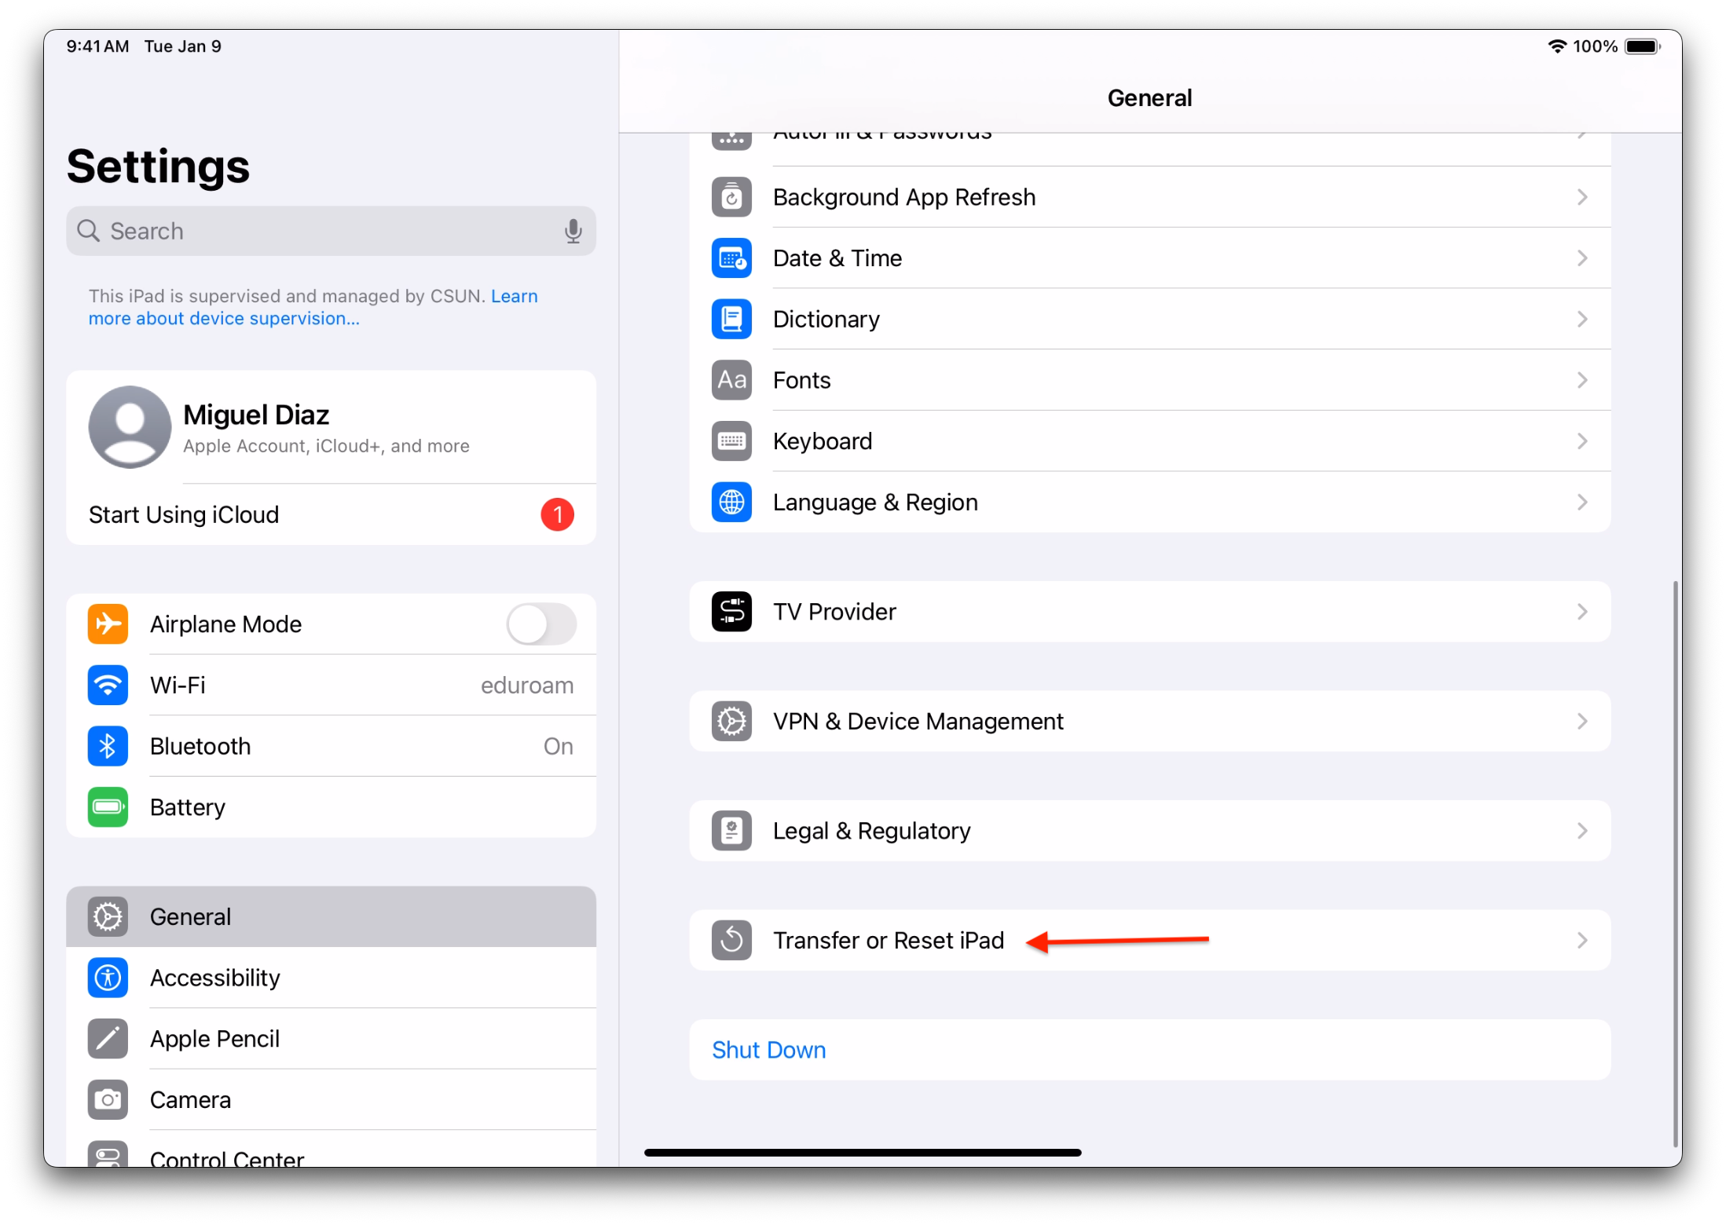

Step 4: Erase the device.
Tap Erase All Content and Settings.
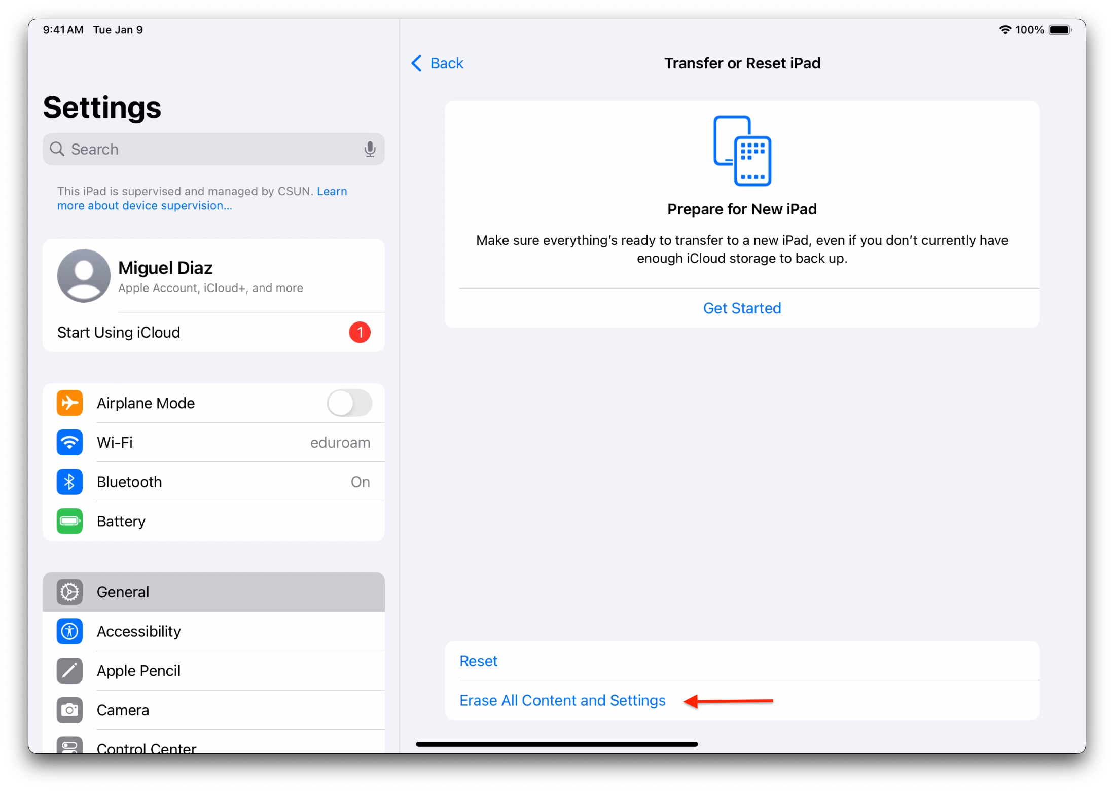

Step 5: Enter credentials if prompted.
Enter your lock screen passcode.
Enter your Apple ID password if requested.

Step 6: Confirm reset.
Tap Continue.
Then tap Erase iPad.
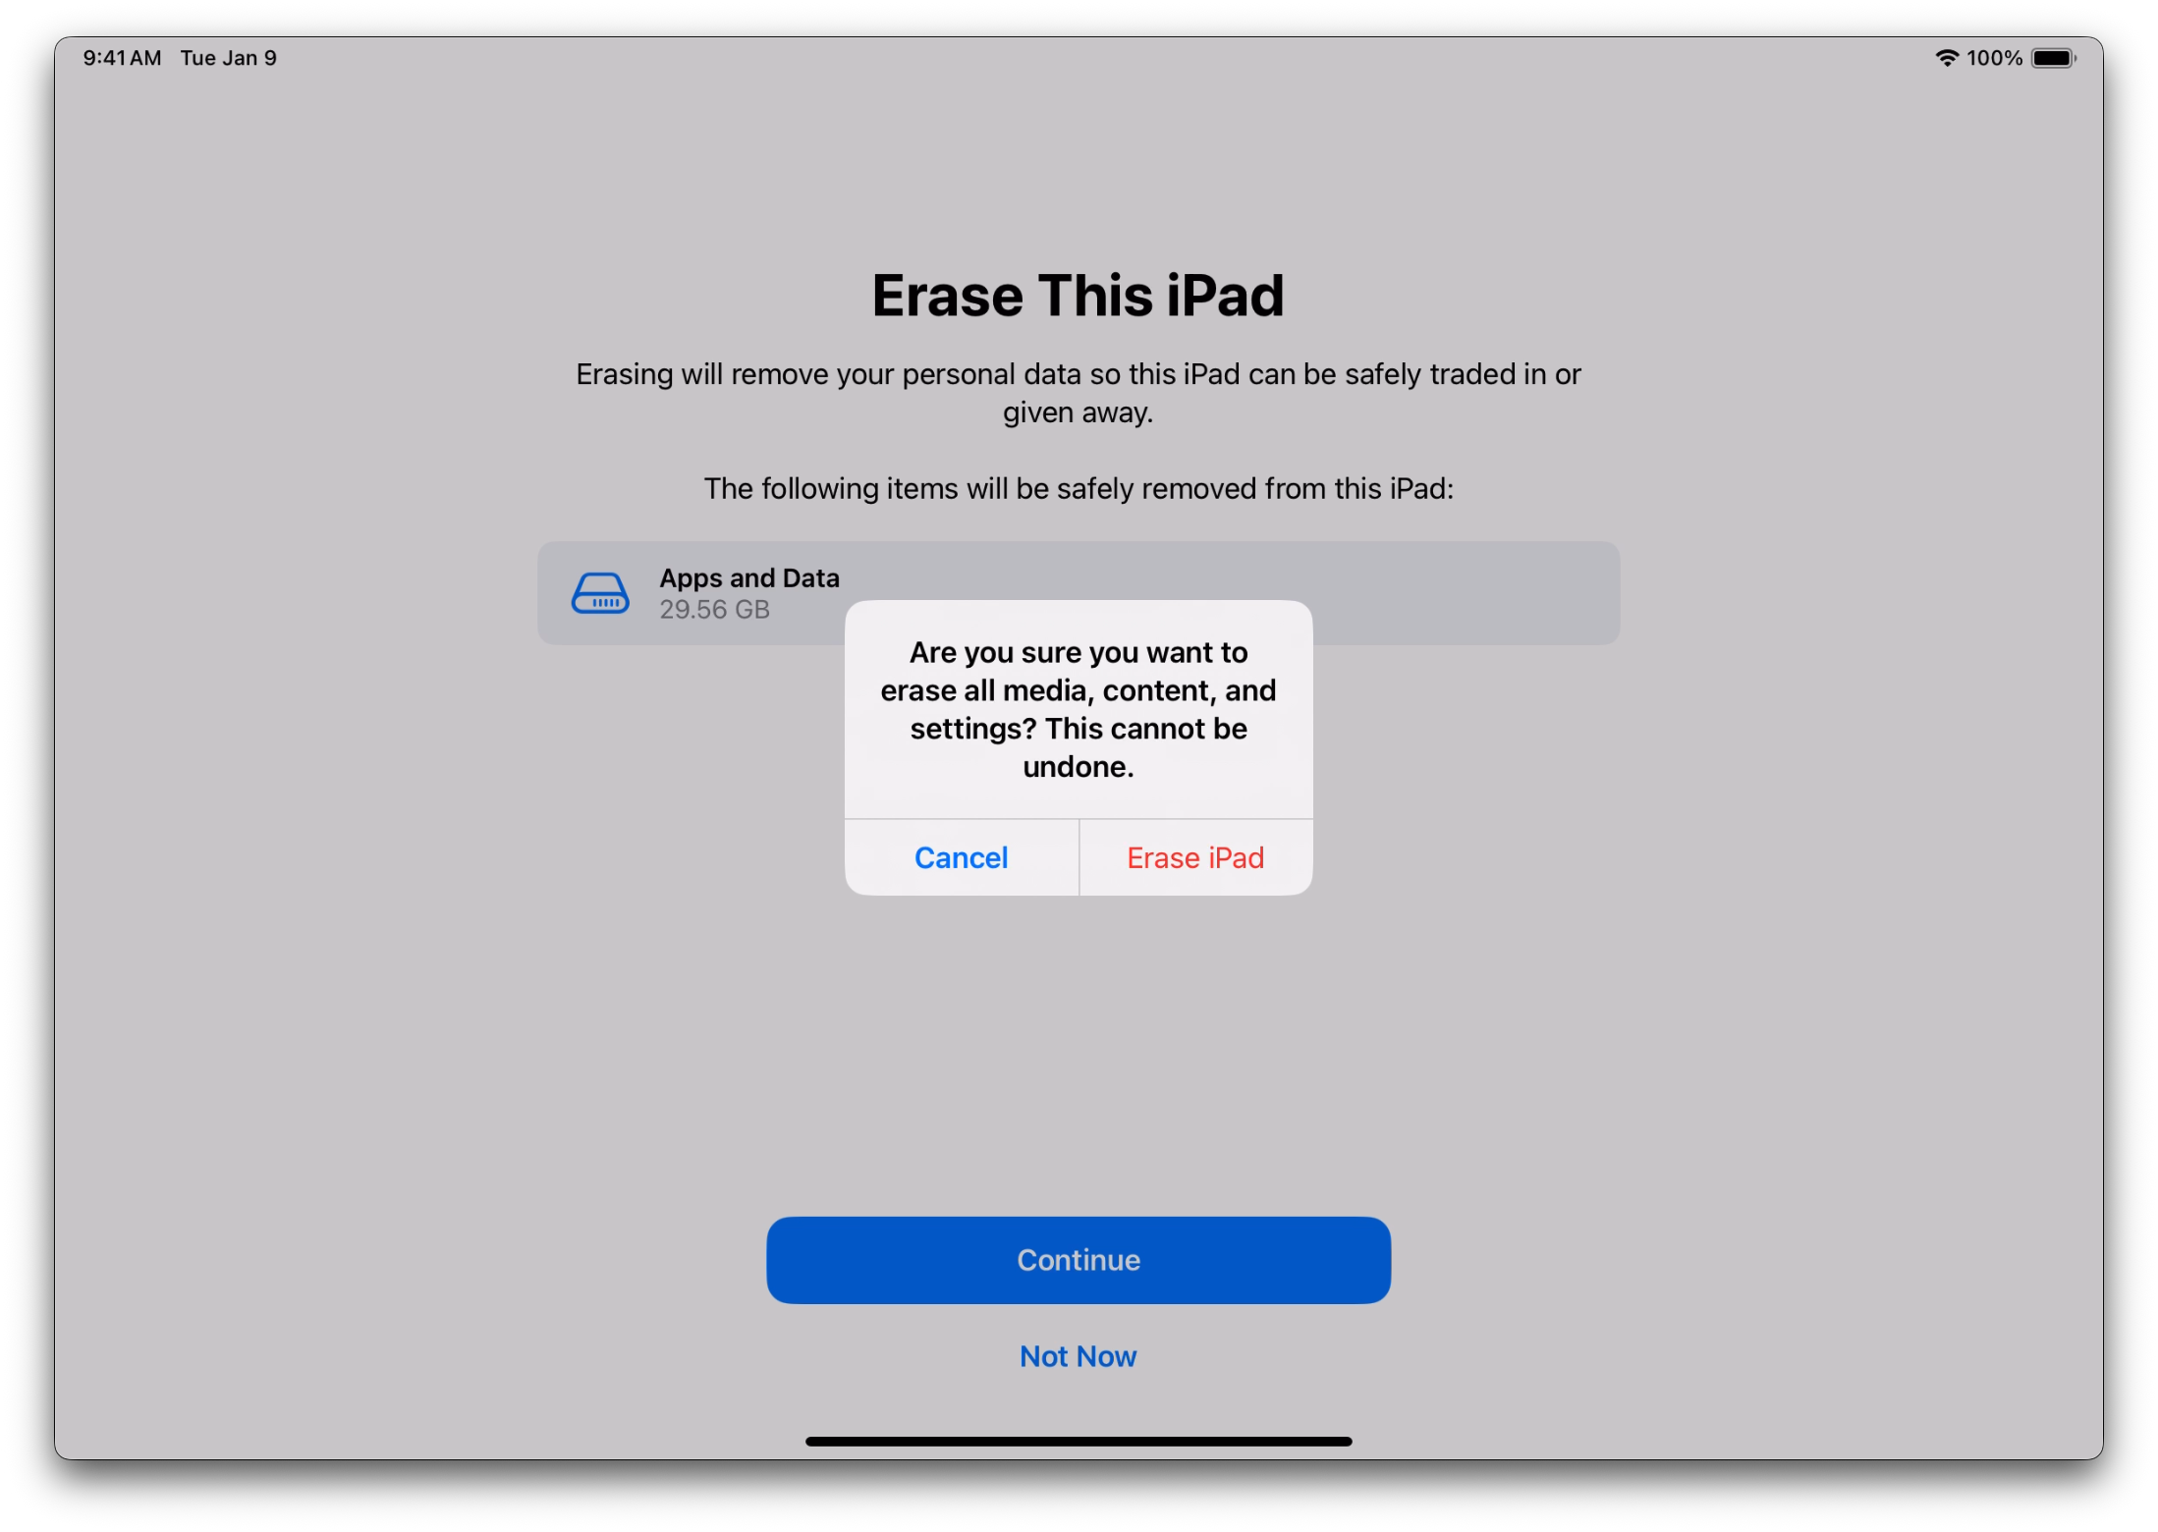
Step 7: Wait for reset to complete.
The iPad will restart and display a black screen with an Apple logo and progress bar. This may take several minutes.

Step 8: Confirm reset is complete.
When the screen shows “Hello,” the reset is complete and the iPad is ready for setup.



Troubleshooting Common Issues

- I am unable to reset the iPad because Find My is enabled.
  - Disable Find My by navigating to:
Settings > Apple ID > Find My > Find My iPad and turning it off.
You will need both your device passcode and Apple ID password.
- I am unable to disable Find My.
  - Please contact the IT Help Center at 818-677-1400 or visit the Ask-a-Tech help desk located on the first floor of the library near the back wall.
- My iPad did not actually reset.
  - Please contact the IT Help Center at 818-677-1400 or visit the Ask-a-Tech help desk located on the first floor of the library near the back wall.

For any issues not covered here, please contact the IT Help Center at 818-677-1400 or visit the Ask-a-Tech help desk located in the first floor of the library towards the back wall.

