iPad Setup Guide
Step 1: Start setup.
Swipe up from the bottom of the screen on the “Hello” screen.
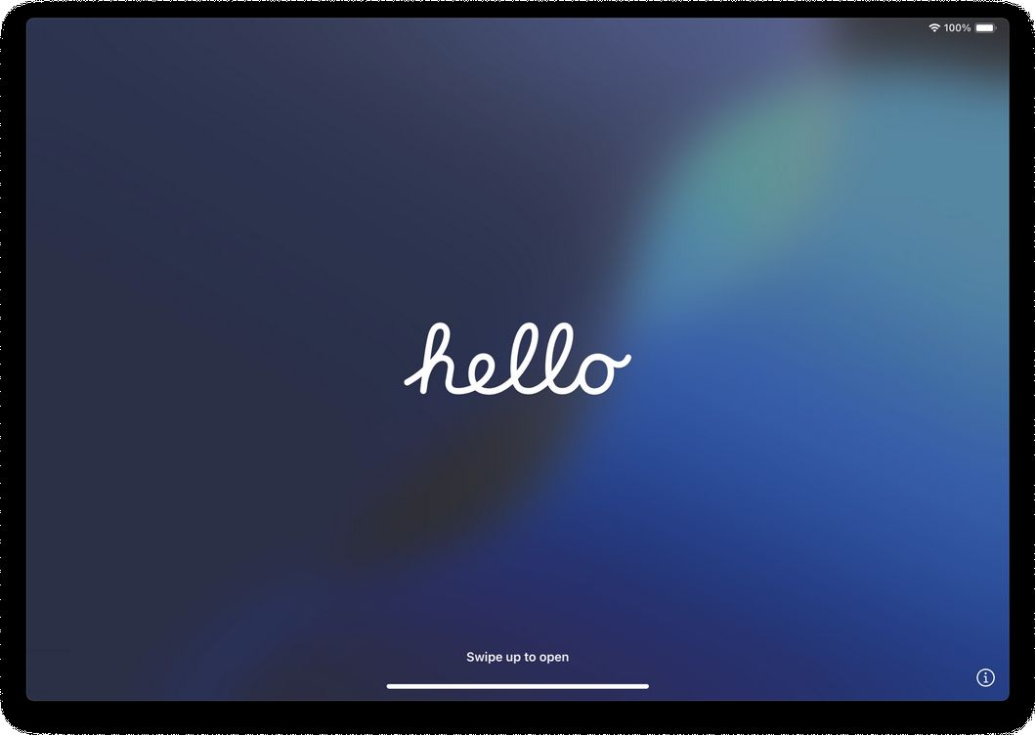
Step 2: Select basic settings.
Choose your language.
Choose your country or region.
Select your preferred appearance
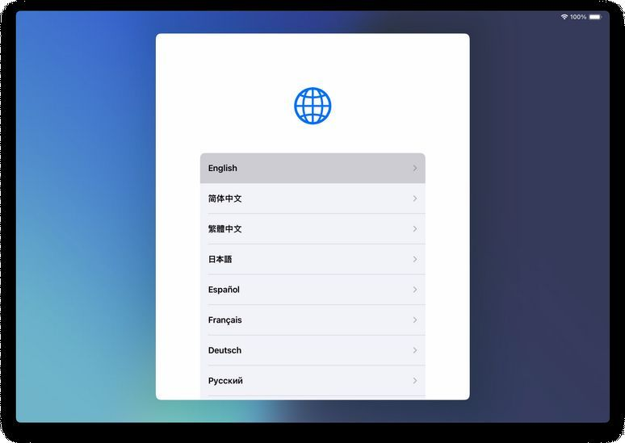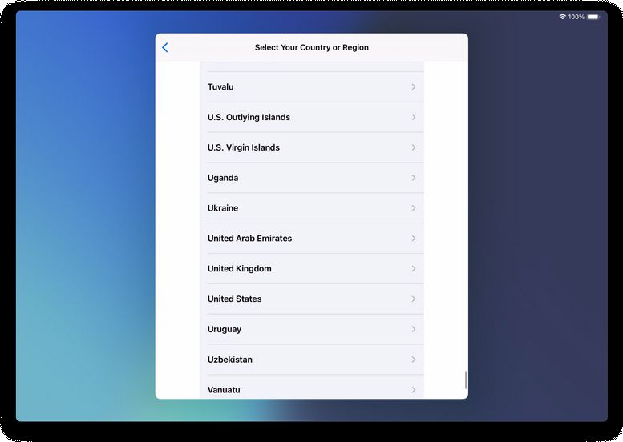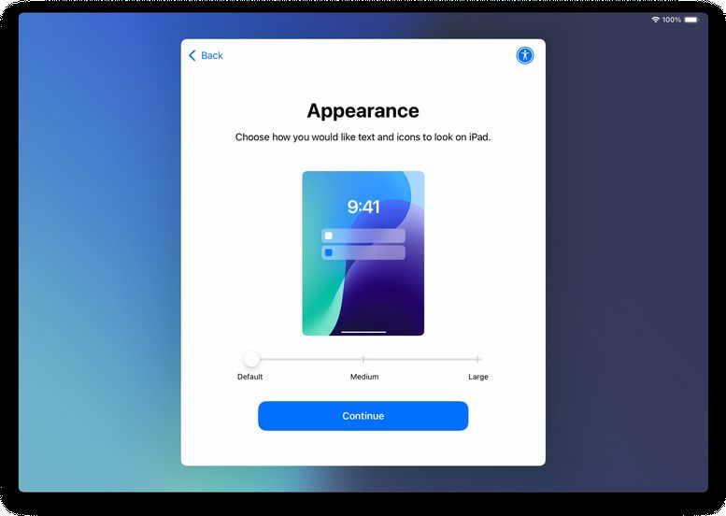

Step 3: Quick Start option.
If you have another Apple device, you can use it to automatically set up this iPad.
Otherwise, tap Set Up Without Another Device or Set Up Manually
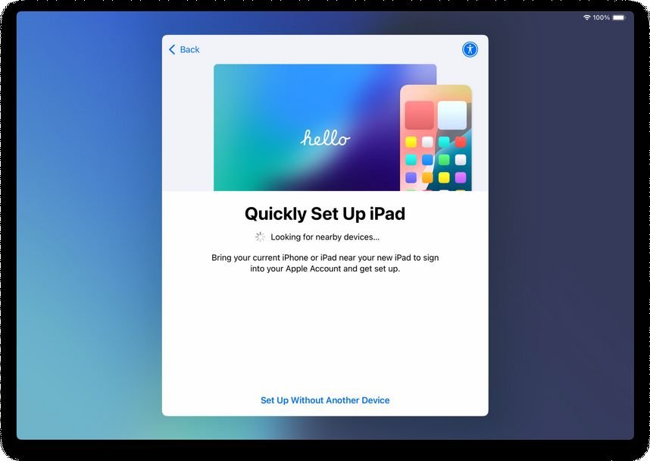
Step 4: Connect to Wi-Fi.
Select a wireless network and enter the password. If on campus select “Eduroam” and sign in with your CSUN credentials.
Wait for the iPad to activate.
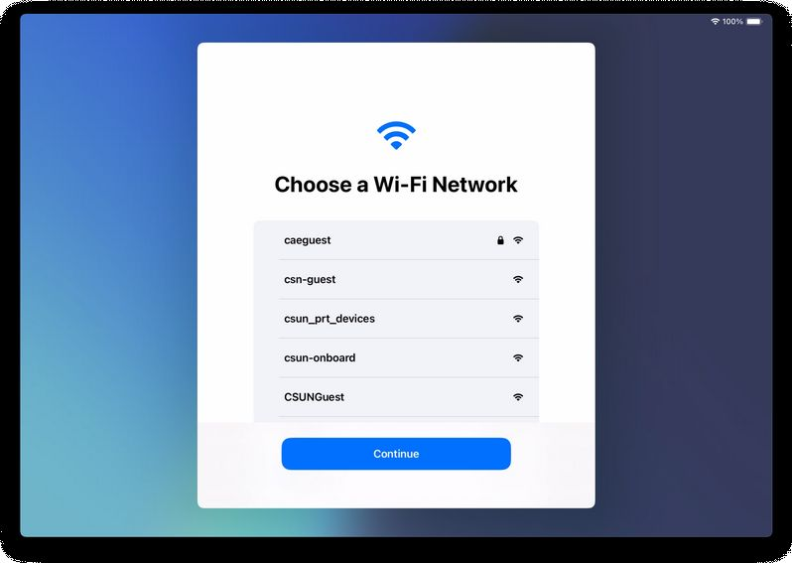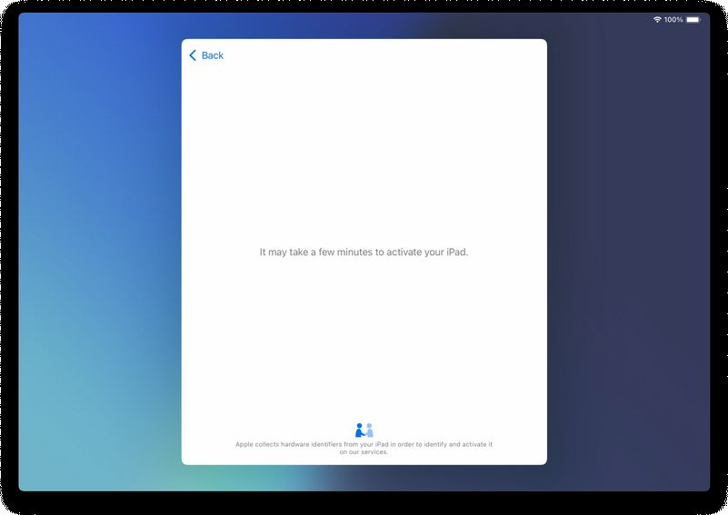

Step 5: Handle Activation Lock (if prompted).
If you see a screen indicating the device is linked to an Apple ID, enter your Apple ID credentials to continue.
WARNING: You must use the Apple ID previously associated with the device. If you cannot sign in, contact the Help Desk.
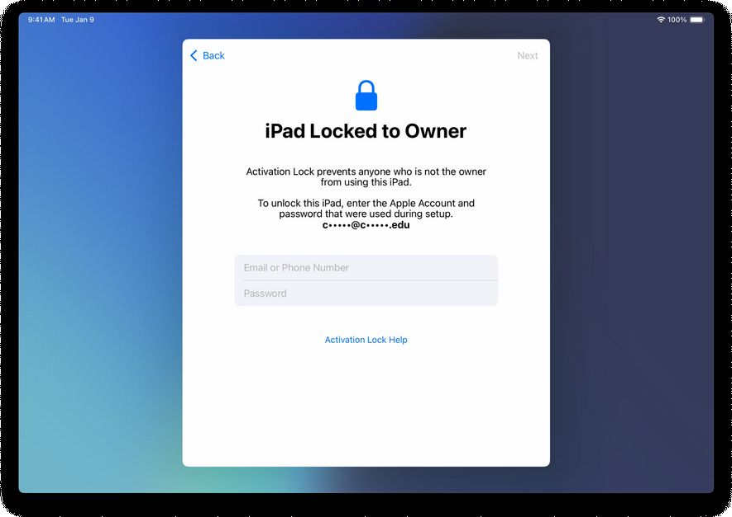

Step 6: Enroll the iPad.
Tap Next or Enroll This iPad when prompted.
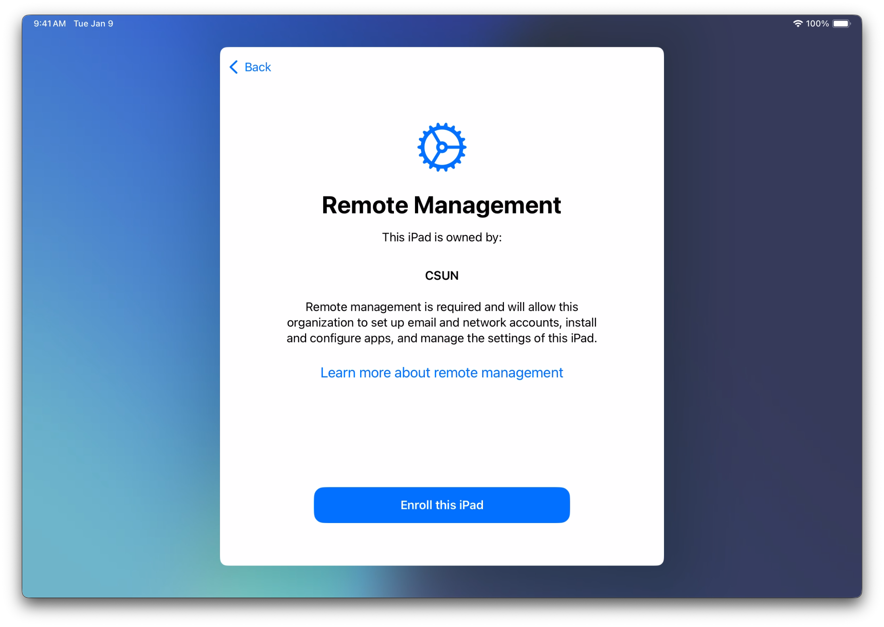
Step 7: Sign in with your CSUN account.
Enter your CSUN email address. IF asked select Work or school account DO NOT select personal account.
Then enter your SSO login credentials. Authenticate with Duo when asked.
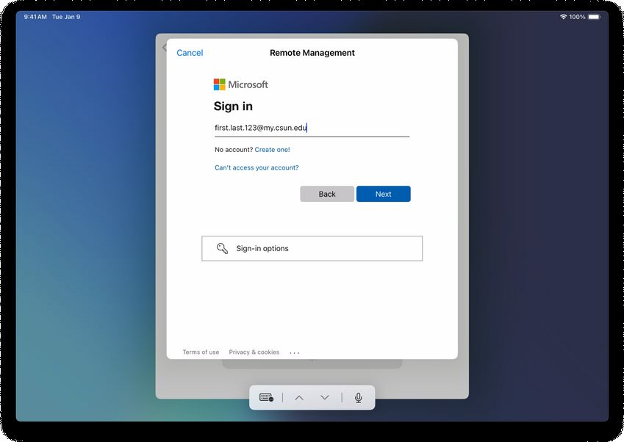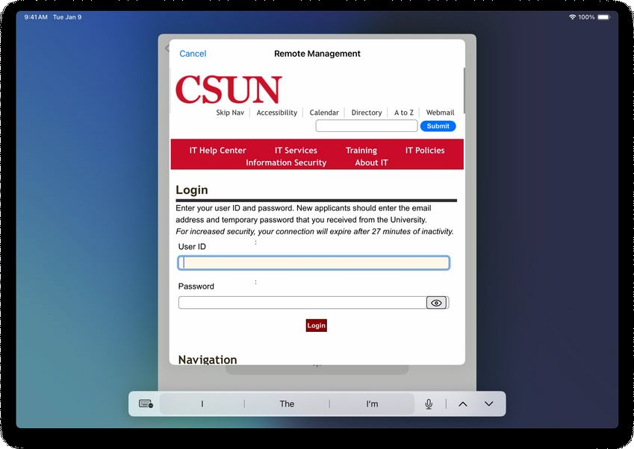

Step 8: Wait for enrollment to complete.
When you see “Configuring iPad,” enrollment is in progress.
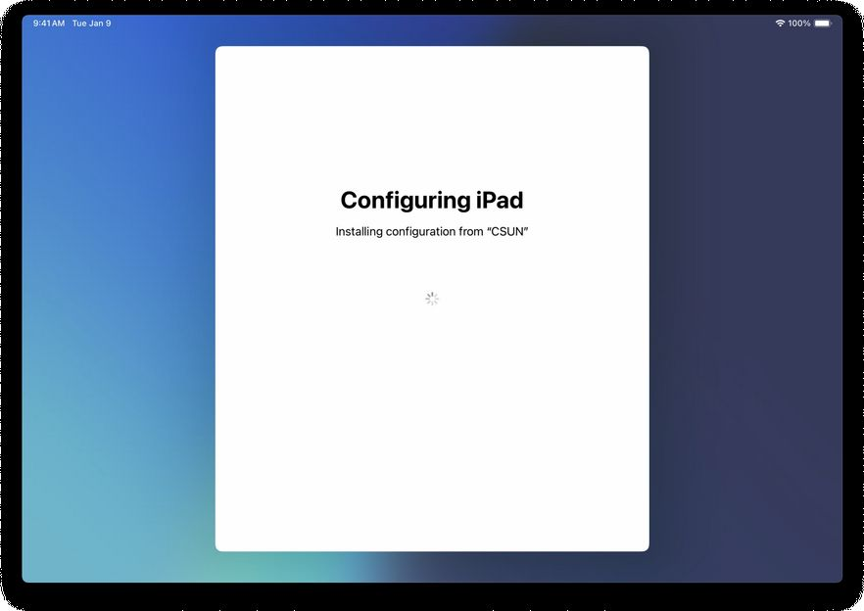
Step 9: Finish setup.
Continue through the remaining setup steps.
Once complete, your iPad will proceed to the homescreen. Please finish registering your device with the Company Portal app.

Step 10: Locate and open the Company Portal app.
Find the Company Portal app on your iPad. It is usually on the second page of the Home Screen. If you don’t see the Company Portal please wait a few minutes before proceeding.

Step 11: Tap the blue Sign In button.
Hit Sign In then enter your CSUN email address
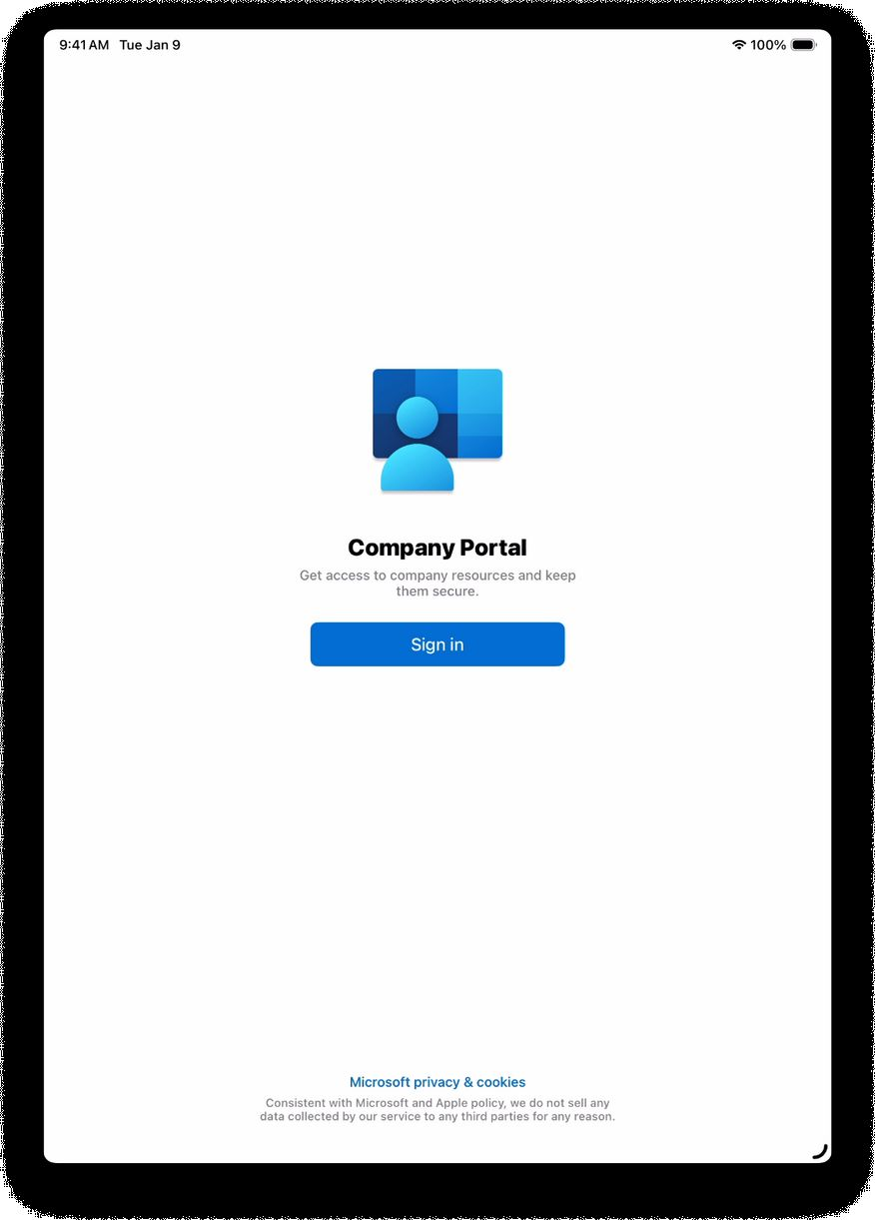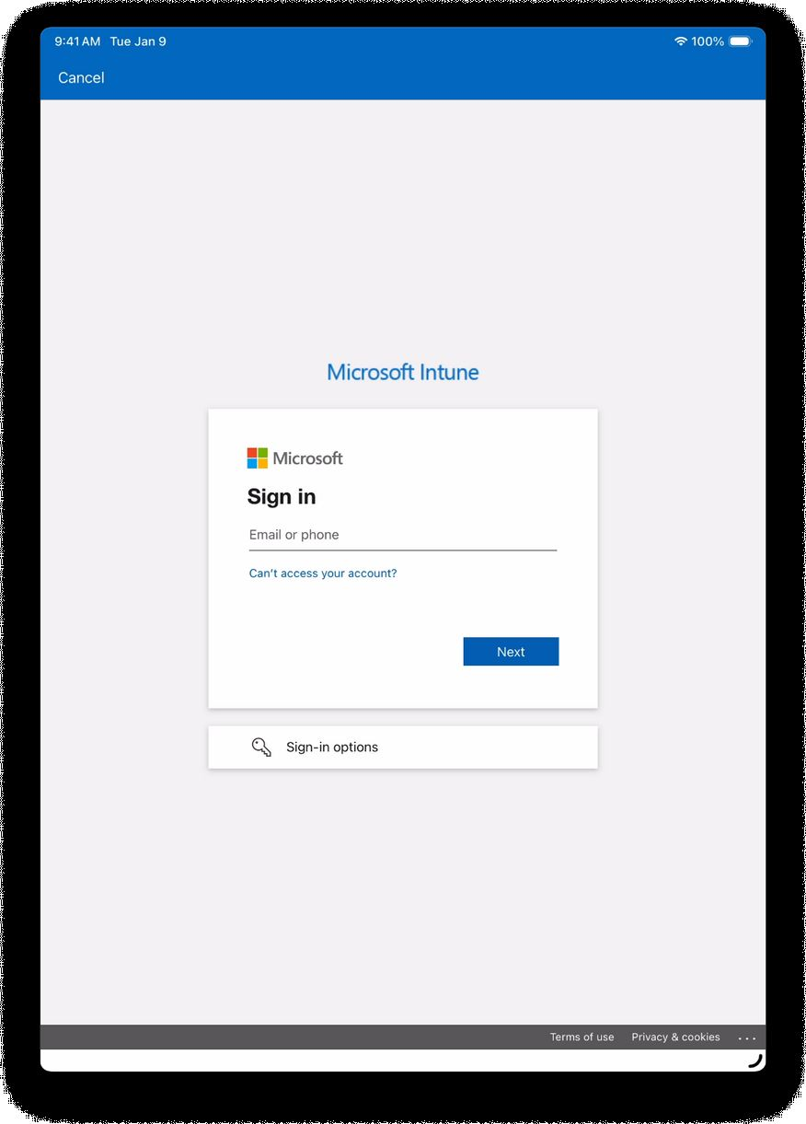

Step 12: You will be redirected to the CSUN login page.
*If you did not update your device earlier you may not be able to complete this section*
Enter your CSUN credentials and complete Duo authentication.

NOTE If prompted to update Company Portal click cancel. You may be prompted several times please click cancel you complete this process.

Step 13: Tap OK on the next screen, then tap Allow when prompted
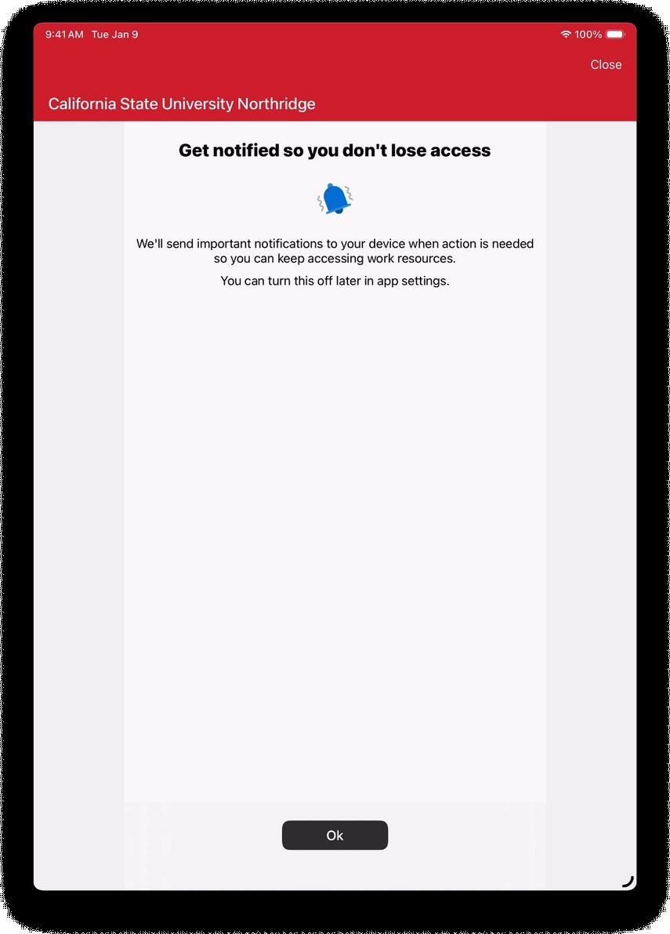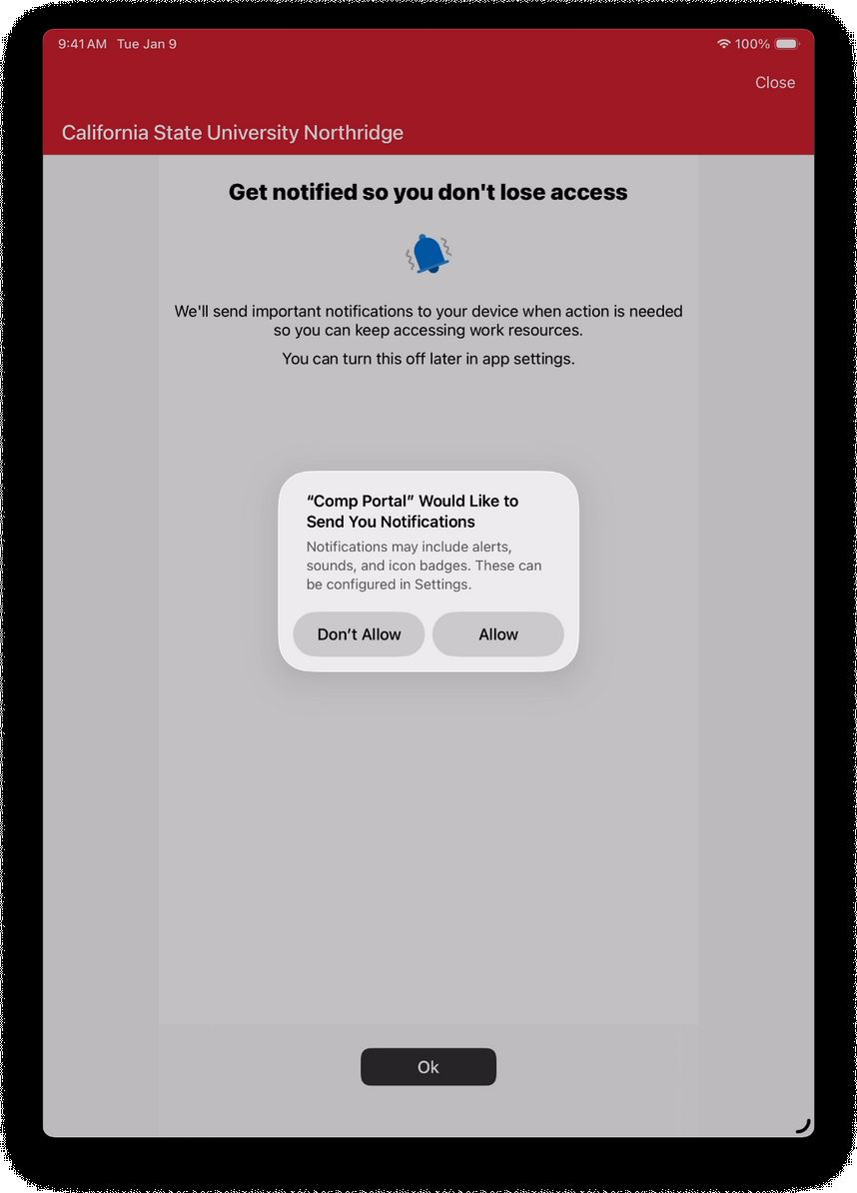

Step 14: Tap Begin on the next screen.
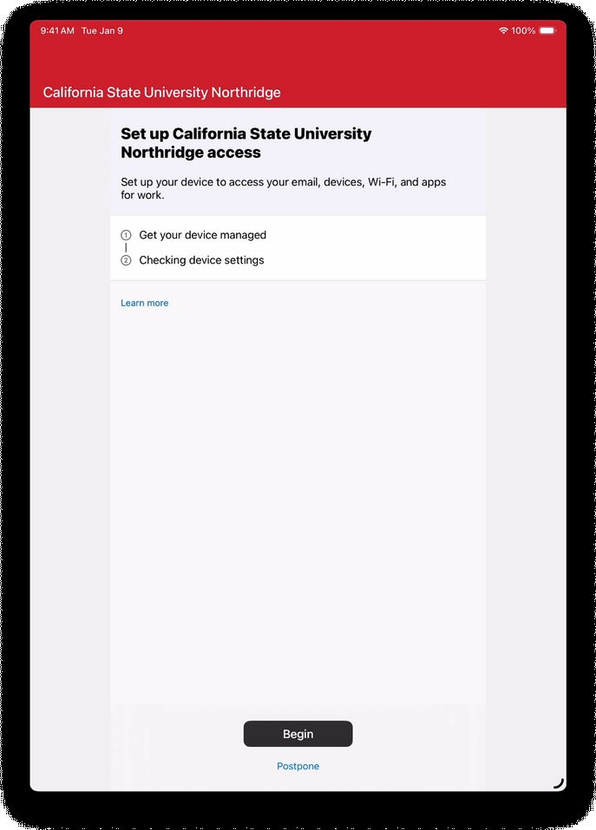

Step 15: Select your preferred verification method for CSUN Microsoft account. If you do not have one set up, follow the steps below to setup to setup MFA with the DUO application.

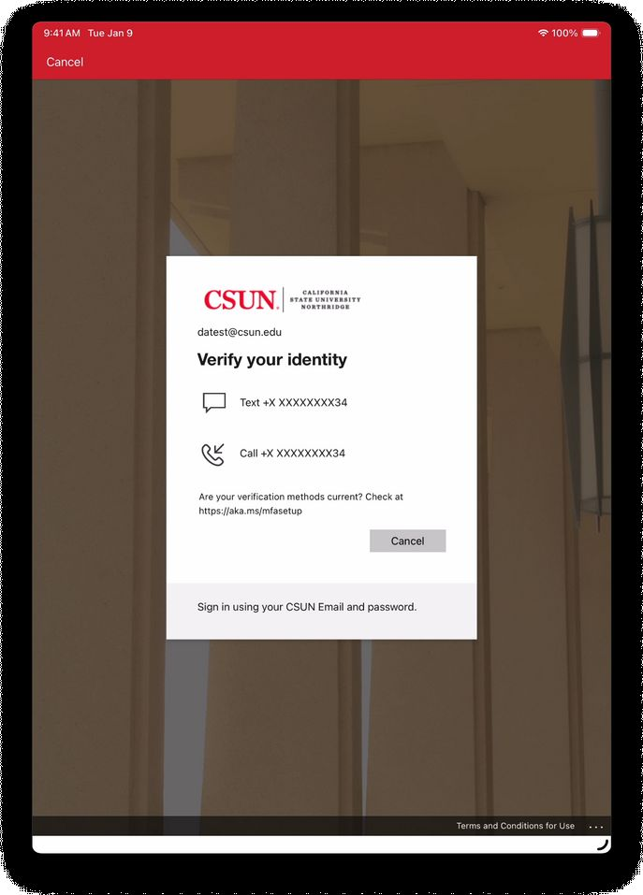
Microsoft Account DUO Setup
- Select “I want to sue a different authenticator app”
- Open Duo app on your phone, touch “Add” then touch “Use QR code”.
- Scan the QR code and enter the 6 digit code when asked.
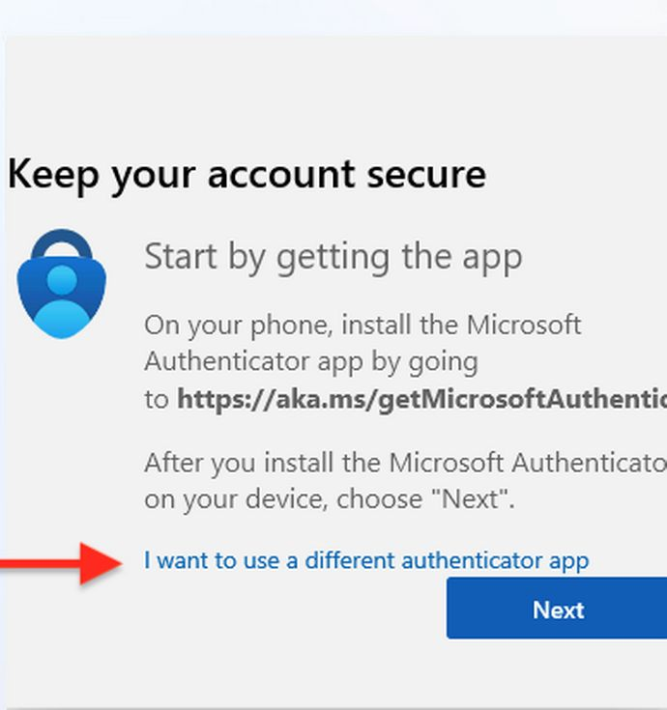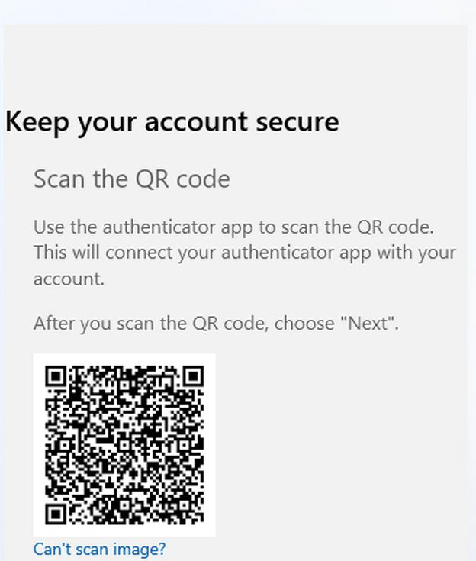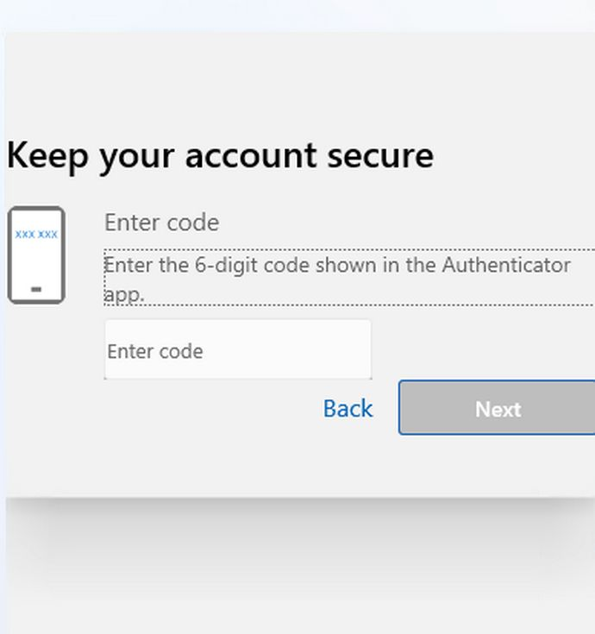

Step 16: Once verification is complete, tap Done.

Step 17: Setup is complete browse the company portal for available apps or proceed to using your DLP iPad

Troubleshooting Common Issues

- I am unable to authenticate during Step 15.
OR
- I no longer have access to the authentication method shown during Step 15.
a. This is separate from Duo MFA. Your existing Duo MFA is not tied to your CSUN Microsoft account. Please follow the setup instructions above or contact the IT Help Center for assistance resetting your CSUN Microsoft account MFA.
- I was not asked to sign in with my CSUN Microsoft account during setup.
OR
- I see a Self Service app instead of Company Portal.
a. Please return the device to the library Guest Services desk.
- I do not see the Company Portal app.
a. Please allow a few minutes for Company Portal to finish downloading to the device.
- I receive a “Profile Installation Failed” error message.
a. Shut down the iPad by holding the Power and Volume Up buttons, then slide to power off. Turn the iPad back on and attempt setup again.

For any issues not covered here, please contact the IT Help Center at 818-677-1400 or visit the Ask-a-Tech help desk located in the first floor of the library towards the back wall.

