CD 485 --- Wednesday, June 29, 2016
Do we have catalog records (for the journal) or Find Text menus for these 2 citations?
(Thiemann-Bourque, 2012) and (Schlosser & Wendt, 2008)

___YES _____ NO Yes_____ No_________

HINT: Using the link -- Looking for a specific Article at http://library.csun.edu/FindResources/ArticlebyTitle
Look up the DOIs:
10.1044/aac21.4.159
10.1044/1058-0360(2008/021)

Schlosser, R. W., & Wendt, O. (2008). Effects of Augmentative and Alternative Communication Intervention on Speech Production in Children With Autism: A Systematic Review. American Journal of Speech-Language Pathology, 17(3), 212-230. doi:10.1044/1058-0360(2008/021)
Thiemann-Bourque, K. (2012). Peer-mediated AAC instruction for young children with autism and other developmental disabilities. Perspectives on Augmentative and Alternative Communication, 21(4). doi:10.1044/aac21.4.159
Example of find text menu

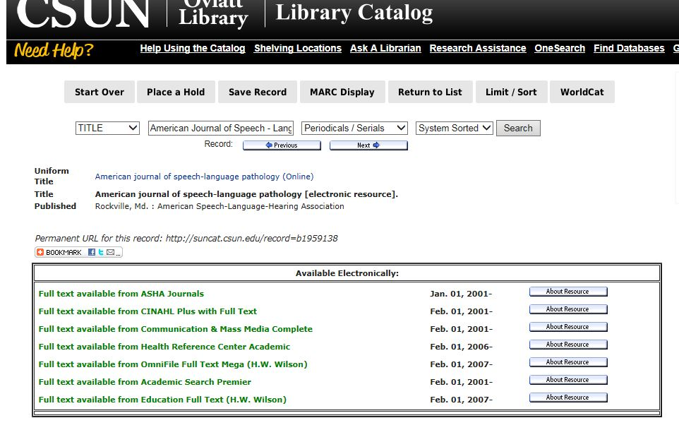
Databases currently recommended for Communication Disorders –select list
*PubMed – be sure to connect to Oviatt’s link – the URL at the top of page should show http://www.ncbi.nlm.nih.gov/pubmed?otool=cacsunlib
MEDLINE (ISI) as well as Web of Science – Thomson Reuters database which also offer us EndNote Basic ( also called EndNoteWeb)
*CINAHL Plus with Full Text (EBSCO) -
Some other EbscoHost database which will be helpful also are :
Academic Search Premier
Communication and Mass Media Abstracts
Education Full Text
ERIC
PsycInfo
OmniFile Full Text Mega (H.W. Wilson)
E books
LLBA Linguistics and Language Behavior Abstracts (Proquest ) –
Proquest has other databases of interest, e.g. Dissertation & Theses
Sage Journals
Science Direct
Wiley journals and Cochrane
----finding books
Oviatt Library Catalog –
http://library.csun.edu link to Library Catalog or the books tab on a OneSearch retrieval

Catalog of the CSU Libraries at http://library.calstate.edu/catalog/

WorldCat at http://www.worldcat.org/

